

**CC4057NI\CC4058NI Introduction to Information System**

**60% Group Coursework**

**2024-25 Autumn**

|  |  |  |  |
| --- | --- | --- | --- |
| **Group Name:** | | | |
| **SN** | **Student Name** | **College ID** | **University ID** |
| **1** | Sandeep Meche | **NP01AI4A240011** | **NP01AI4A240011** |
| **2** | Biraj Sharma | **NP01AI4A240124** | **NP01AI4A240124** |
| **3** | Yakendra Bam Rajawar | **NP01AI4A240127** | **NP01AI4A240127** |
| **4** | Abiram Bhatta | **NP01AI4A240144** | **NP01AI4A240144** |
| **5** | Chandani Banjade | **NP01AI4A240131** | **NP01AI4A240131** |

**Assignment Due Date: Sunday, January 19, 2025**

**Assignment Submission Date: Sunday, January 19, 2025**

Word Count**: 11717**

*I confirm that I understand my coursework needs to be submitted online via MySecondTeacher under the relevant module page before the deadline in order for my assignment to be accepted and marked. I am fully aware that late submissions will be treated as non-submission and a marks of zero will be awarded.*

Contents

Turnitin plagiarism check pdf file 3

1. Introduction to Project: 4

2. Aims and Objectives: 4

3. Tools Used for Developing the Website: 4

3.1 HTML5: 4

3.2 CSS3: 5

3.3JavaScript: 5

4. Verdict 5

5. Discussion and Analysis 5

5.2 Tool used for developing wireframe: 5

5.2.1 Balmisq 5

6. Web Pages 6

6.2. Blog Page 8

6.3 First Blog page 10

6.5 Product Page 13

6.8 Research Section 19

6.9 About Us 21

7.Source Code 23

7.1 Main CSS code for the webpage layout 23

7.3 Blog Page CSS Code 40

7.4 Reasearch CSS Code 45

7.5 CV CSS Code 48

7.6 Java Script Code for image slider (Men’s Collection) 54

7.8 Home Page HTML 57

7.9 Blog Page 70

7.8.1 Blog page 75

7.8.2 Blog Page 2 83

7.9 Product Page 93

7.9.1 Men’s Collection Page 98

7.9.2 Female’s Collection 110

7.9.3 Product’s Detail Page 122

7.10 Research Page 126

7.11 About Us Page 130

7.11.1 CV Page 136

8.Conclusion: 147

# Turnitin plagiarism check pdf file



# Introduction to Project:

The project is made with a major focus on building an e-commerce website for a store to sell different types of watches. The website is made user friendly so that it enables users to navigate and browse with ease, providing them with a wide range of watch collections while making it easy to navigate and creating an attractive, responsive design.

# Aims and Objectives:

The project aims to introduce and develop a functional and aesthetically appealing e-commerce website. Through this site, users will be able to browse through various categories of watches, view their descriptions along with the product’s review and make their choices based on it. Furthermore, the website will have a blog page where the users will get news regarding the watch industry and the advancement in watch technology, a research section for conducting research regarding watches, along with a contact form to provide feedback allowing users to engage with the company.

# Tools Used for Developing the Website:

Throughout the development process of the e-commerce website various web technologies along with other applications were used to create a functional and user-friendly platform. The list below shows the tools used.

## 3.1 HTML5:

Html was used to create the overall layout of the website and give structure to the contents. This was made possible using different tags, creating unique sections for each content and then linking it with CSS and JAVA script through classes and IDs.

## 3.2 CSS3:

CSS was used to make the website aesthetically appealing by using the different properties of CSS. Through CSS the website was styled using external, internal and inline CSS creating an appealing design.

## 3.3JavaScript:

JavaScript was used to make the website functional. Using JavaScript, the website was made responsive to the user interaction with the website. Using JavaScript different components of the website such as buttons, image slider, and form validation was made functional and interactive to users’ interaction.

These tools were chosen because they offer flexibility, scalability, and assurance that the website will work seamlessly and efficiently.

# Verdict

This introduction identifies the main objectives and vision for the e-commerce website project. The succeeding sections discuss design methodology, technical implementation, challenges encountered, and the steps taken to overcome them.

# Discussion and Analysis

The below mentions the different tools technologies used for creating the website

5.1 Tool used as Text editor

5.1.1 Visual Studio Code:

Visual Studio Code (VS Code) is an open-source code editor developed by Microsoft**.** It is known for its versatility and is a powerful tool supporting a wide range of programming languages. With features such as syntax highlighting, debugging, multi-root workspaces, and the ability to add extensions, Visual Studio Code (VS Code) has become one of the most popular and versatile code editors for developers. Especially the feature of being able to add extensions makes it easier to customize the workspace as per need, which makes it ideal for both beginners and experienced programmers. It is supported with a more intuitive and powerfully enabled interface for efficiency in coding and enjoyment. Such a code editor integrated tool is VS Code, which allows multiple extensions, so the time factor is saved while being more productive.

## 5.2 Tool used for developing wireframe:

5.2.1 Balmisq  
Balmisq is an intelligent, intuitive platform that enables visualization and analysis of data for insight from complex data sets with much ease. That means intuitive creation of interactive dashboards, on-the-fly reporting, and sharing data insights collaboratively. Having strong integration capabilities, Balmisq allows seamless connectivity with different data sources, hence unified and efficient workflow. It is designed with a user-friendly interface and has been enriched with advanced analytic features, making it the perfect tool for any professional in need of decision-making based on data with efficiency and accuracy.

# Web Pages

6.1 Home Page

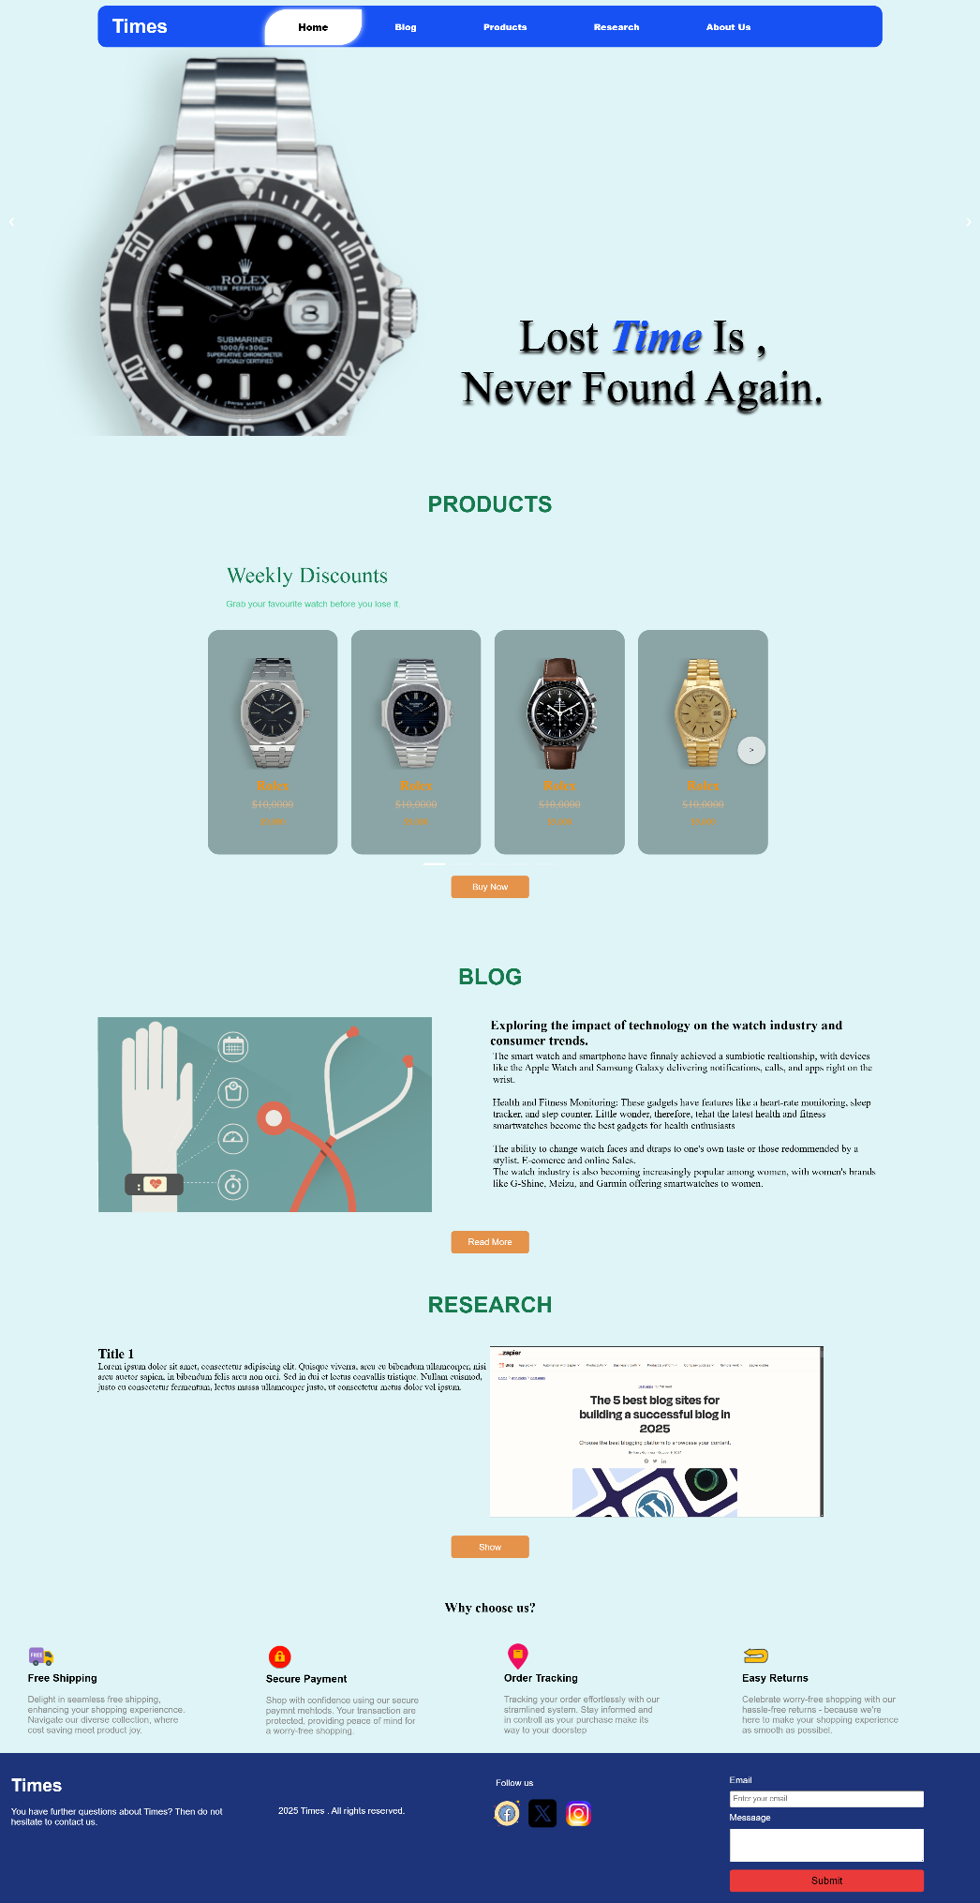

Image 6.1.1

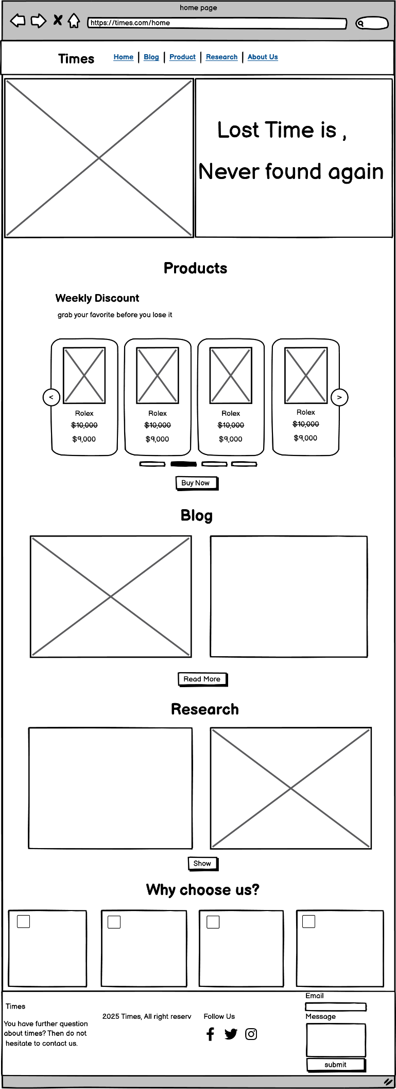

Image 6.1.2

## 6.2. Blog Page

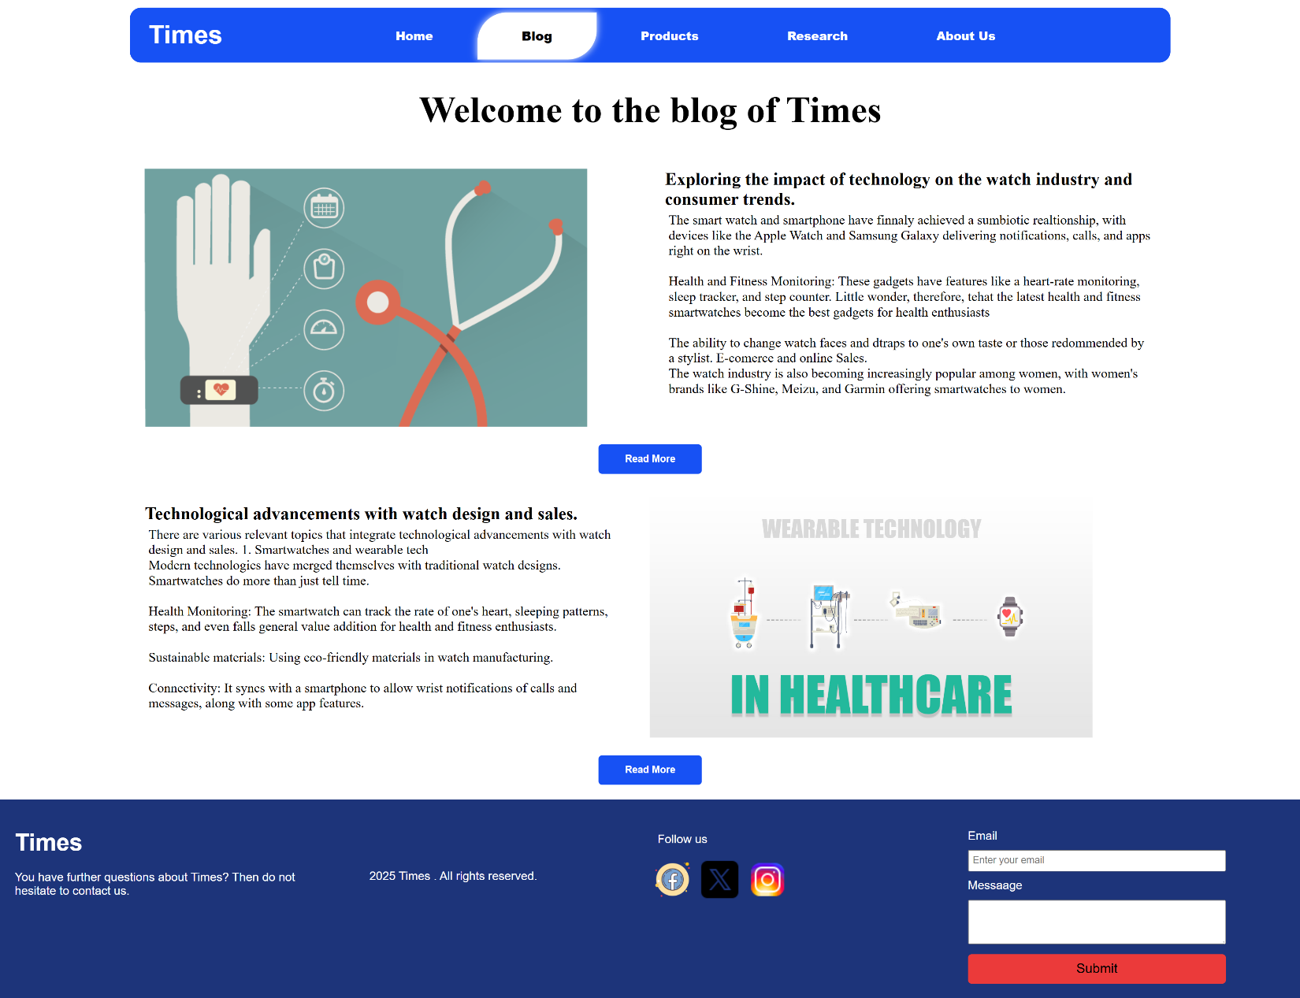

Image 6.2.1

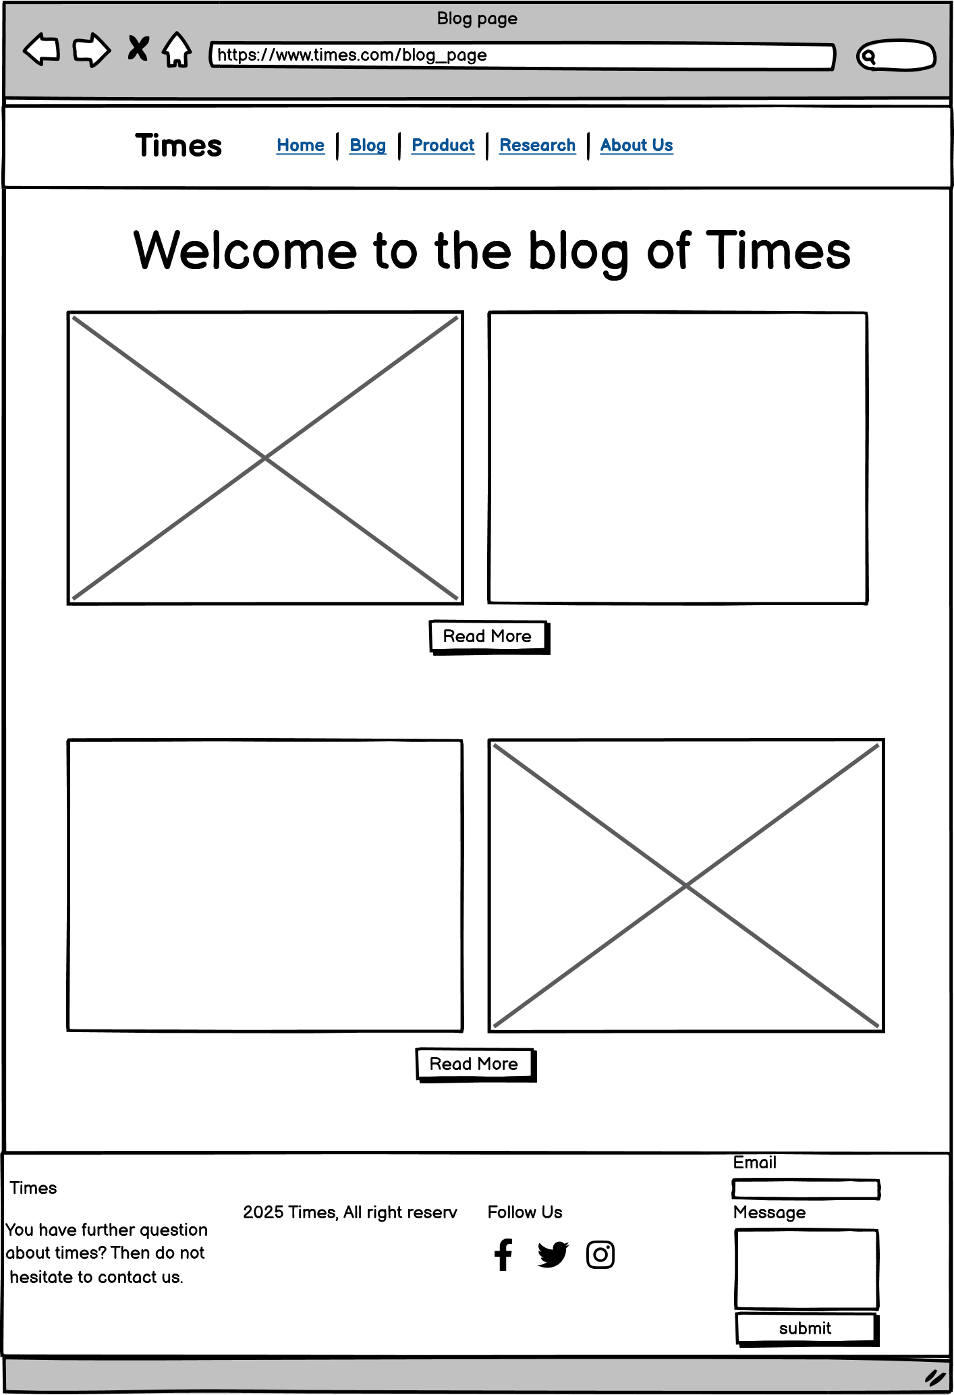

Image 6.2.2

## 6.3 First Blog page

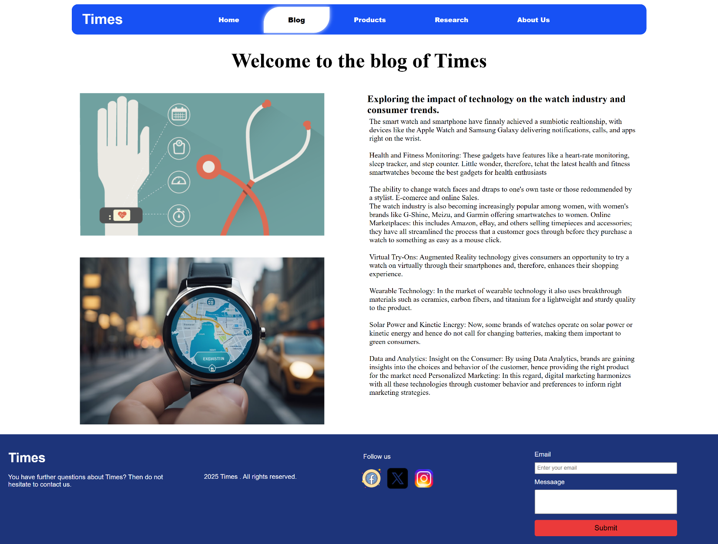

Image 6.3.1

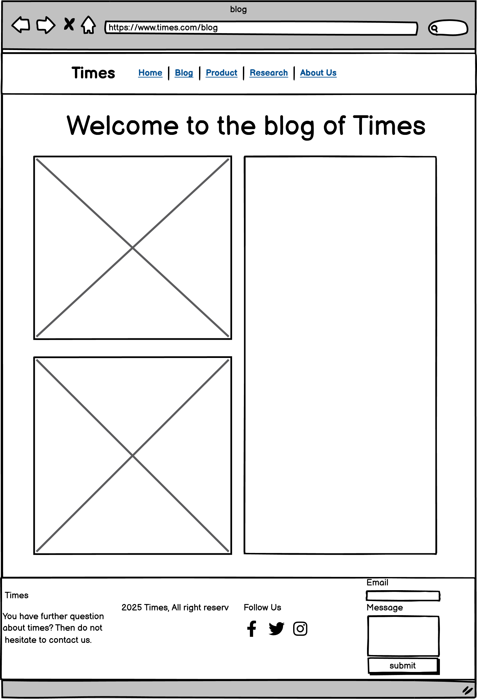

Image 6.3.2

6.4 Second Blog page

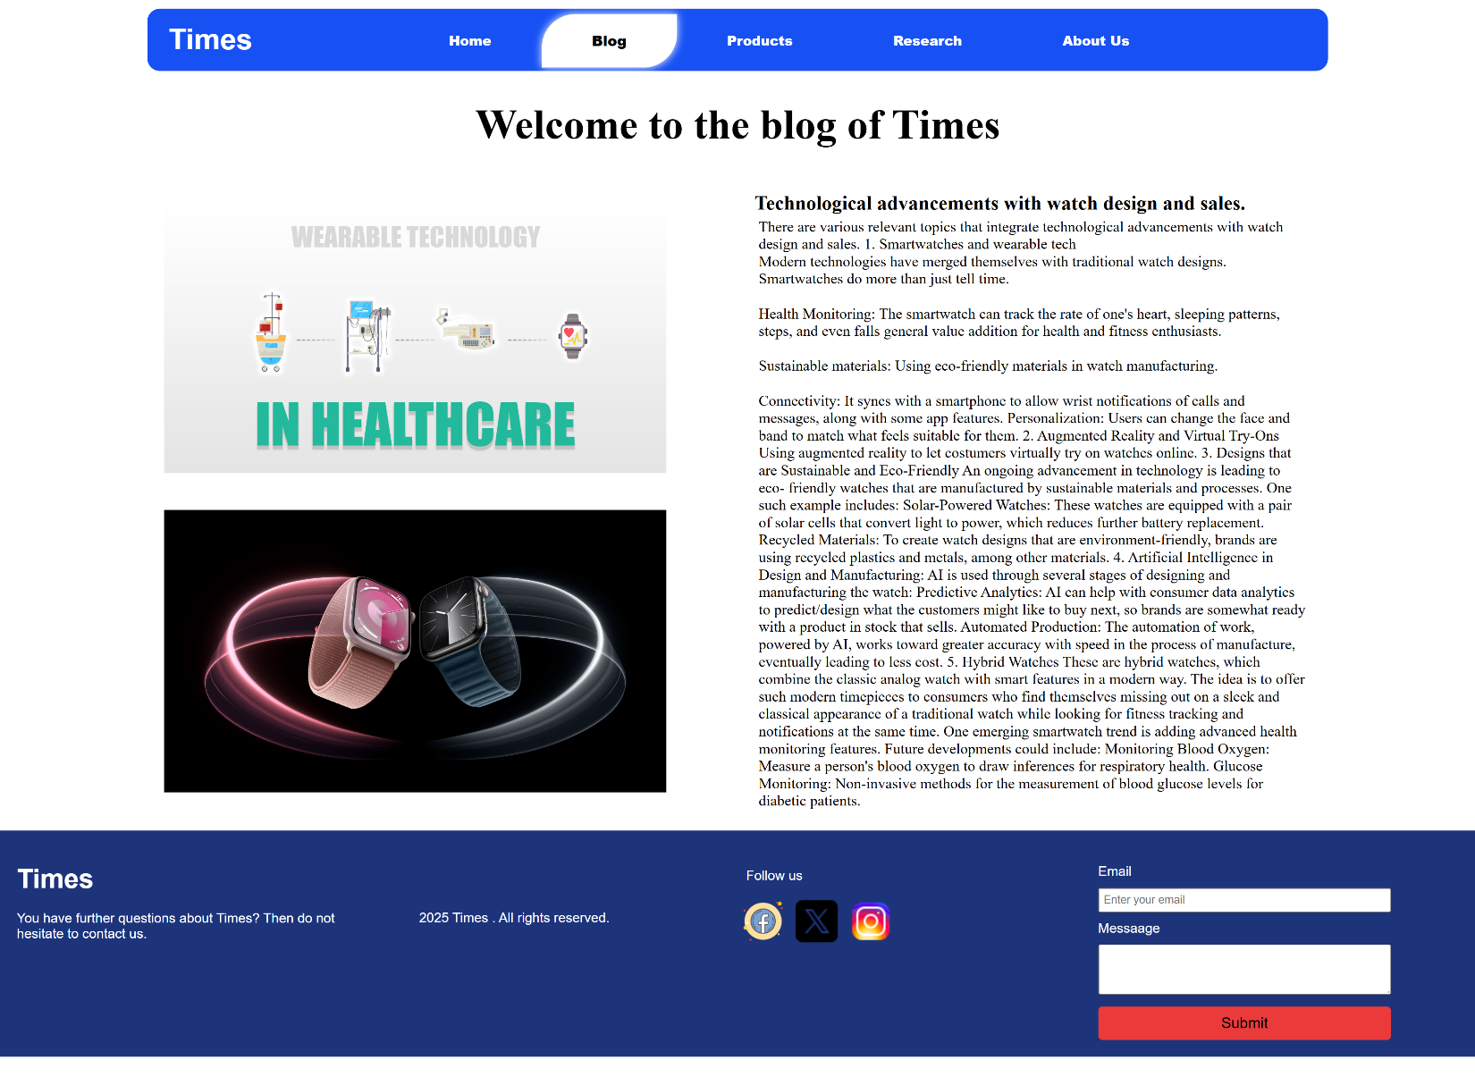Image 6.4.1



Image 6.4.2

## 6.5 Product Page

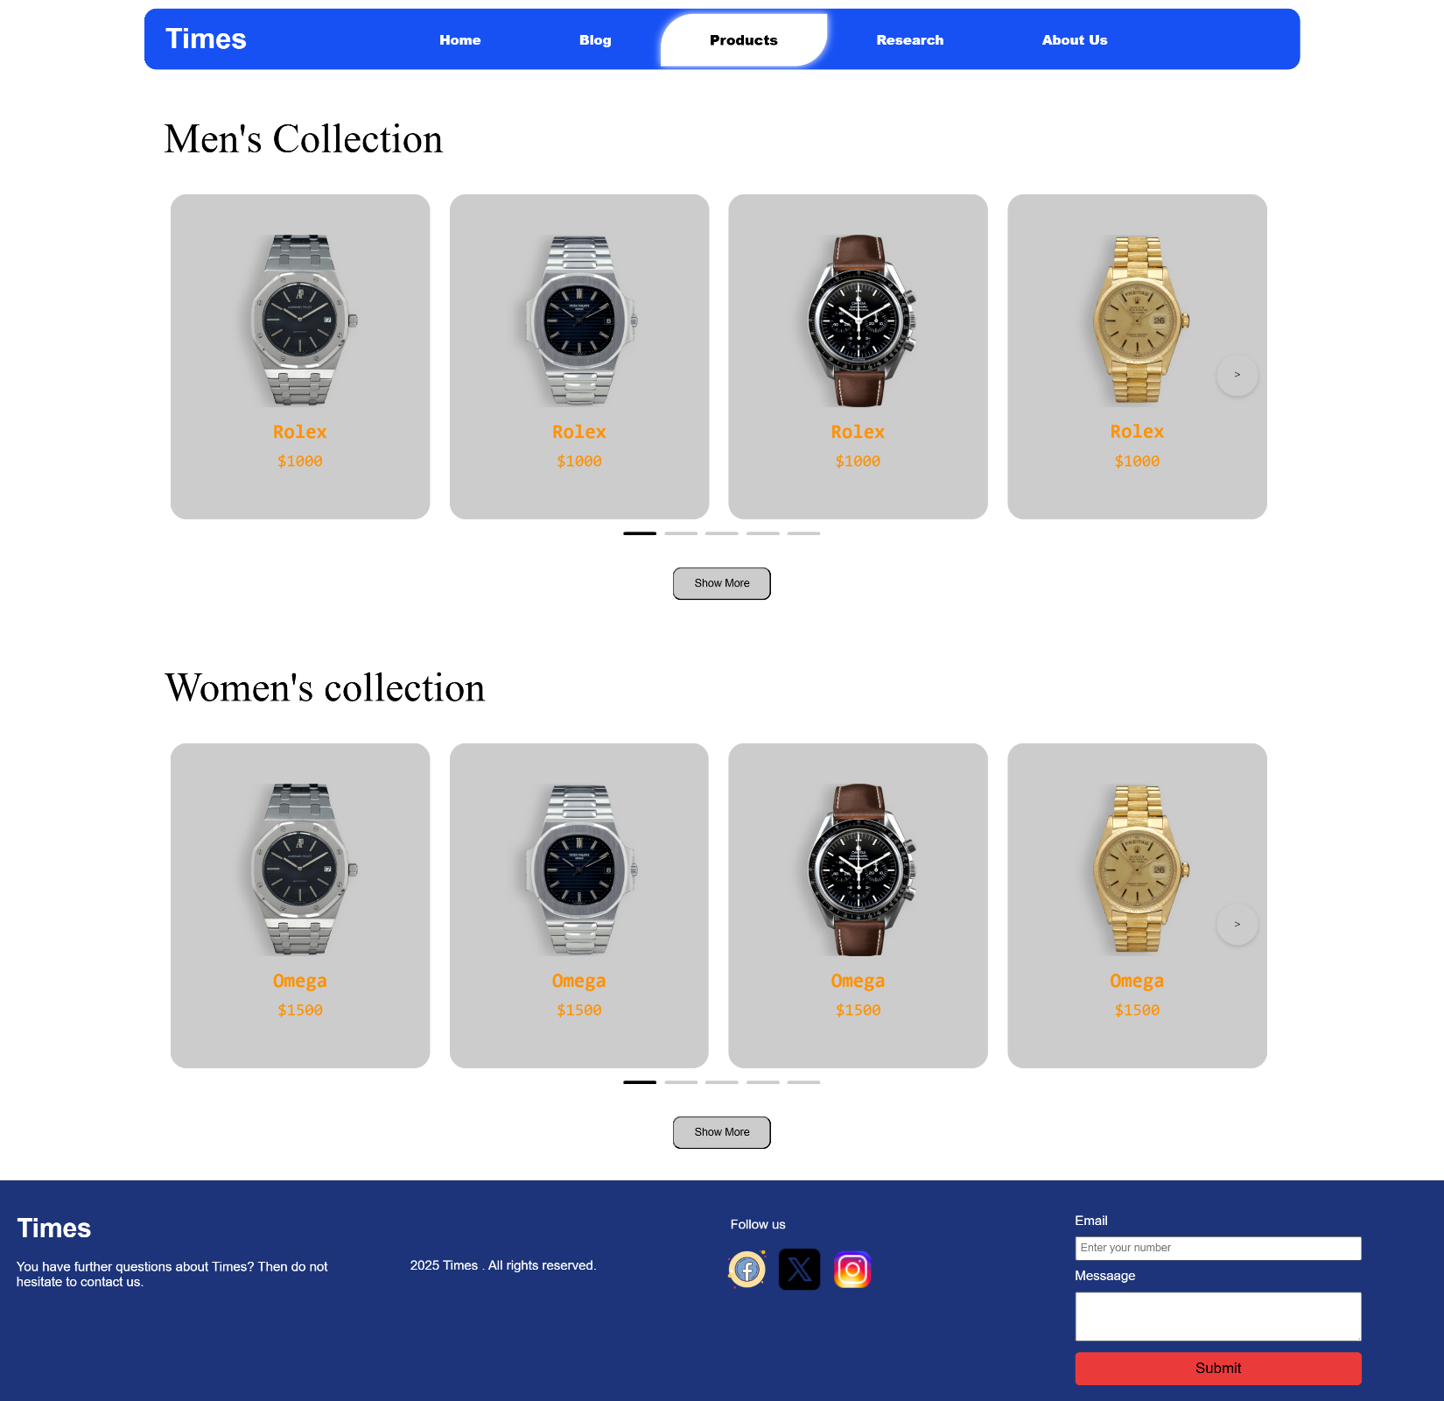Image 6.5.1

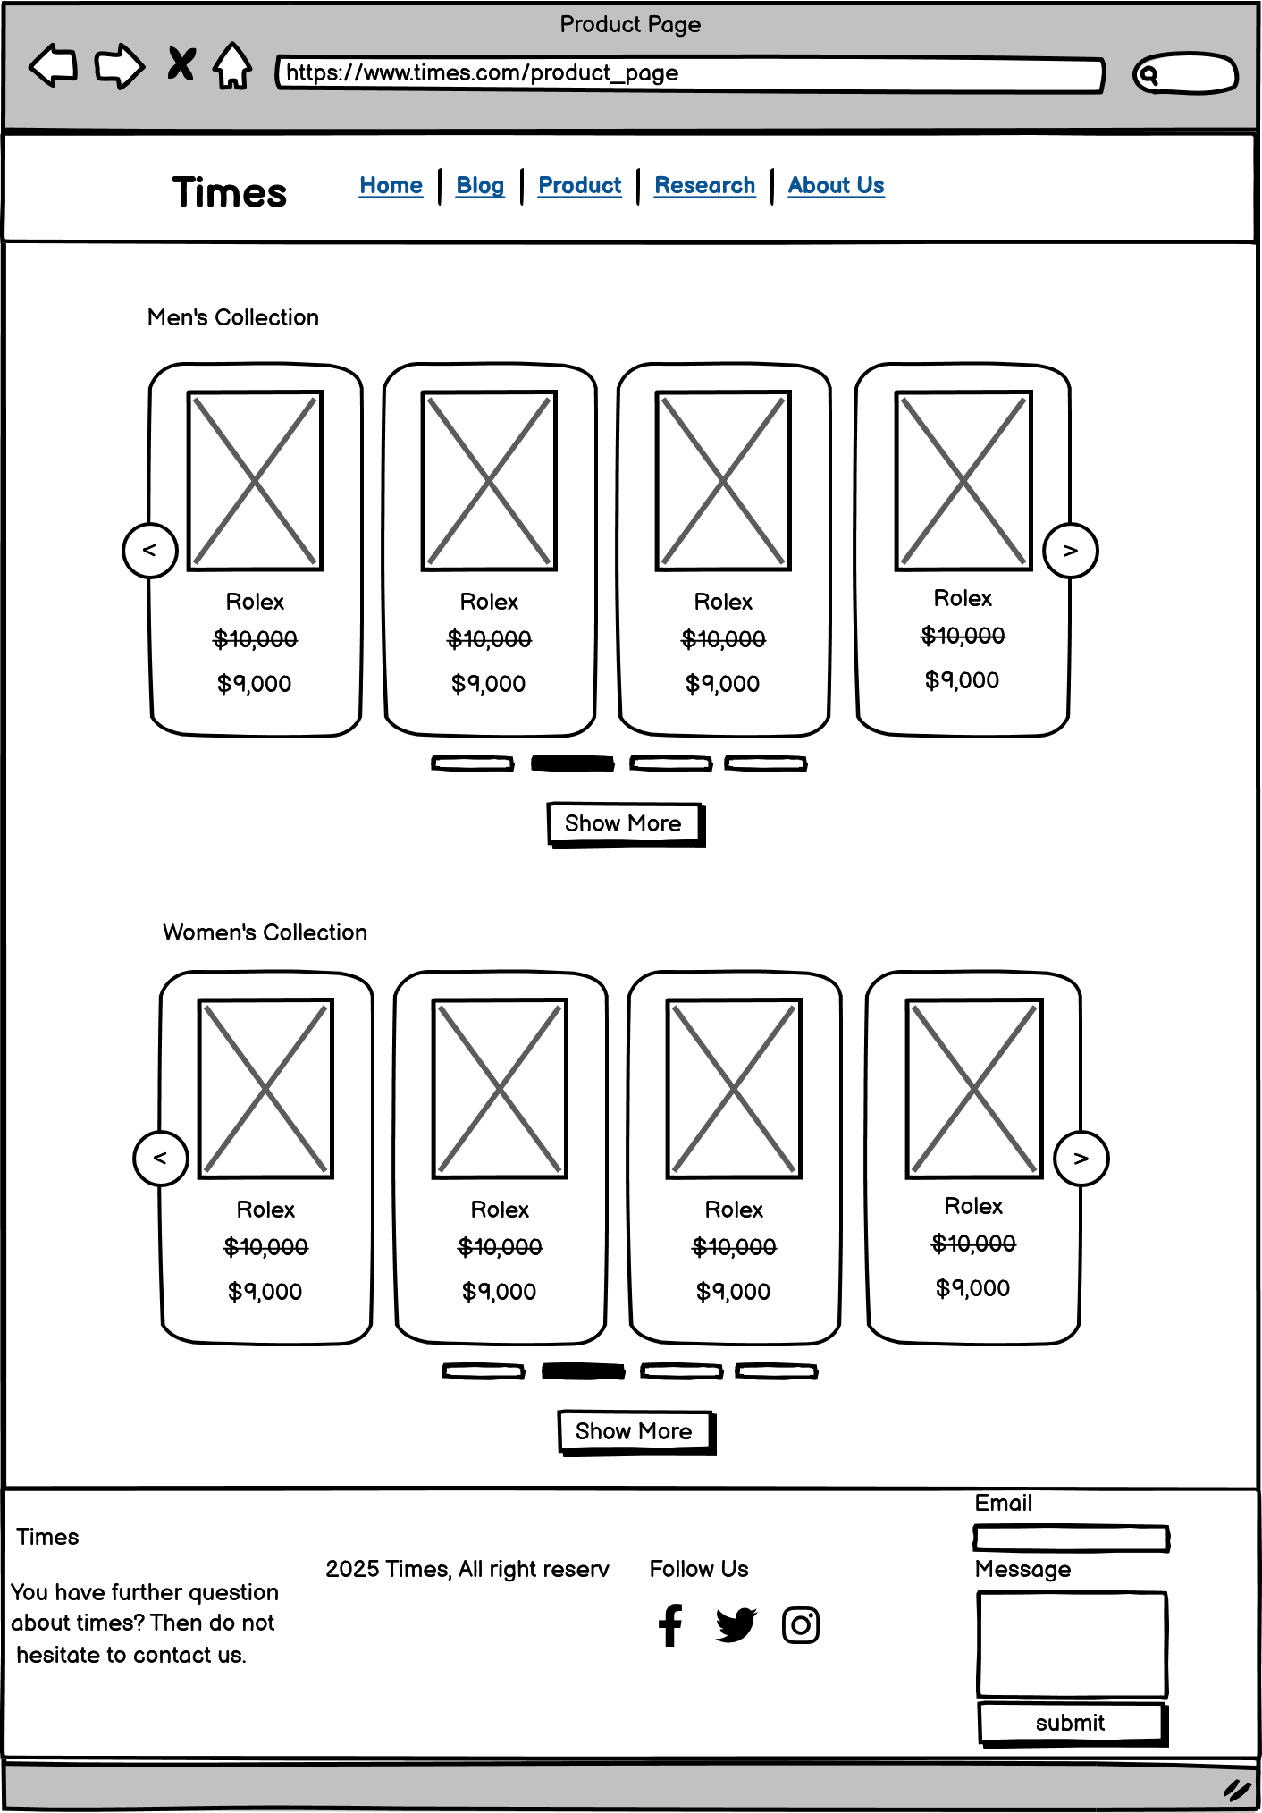

Image 6.5.2

6.6 Men’s Collection/ Women’s Collection

Image 6.6.1

Image 6.6.2

6.7 Product’s Page

Each product has

Image 6.7.1

Image 6.7.2

## 6.8 Research Section

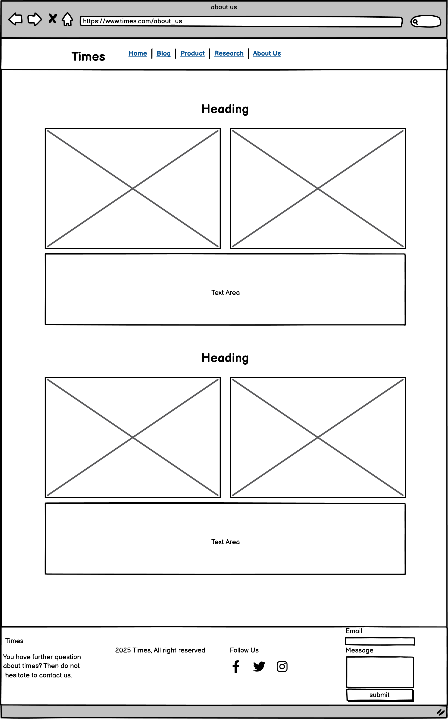

Image 6.8.2

## 6.9 About Us

Image 6.9.1

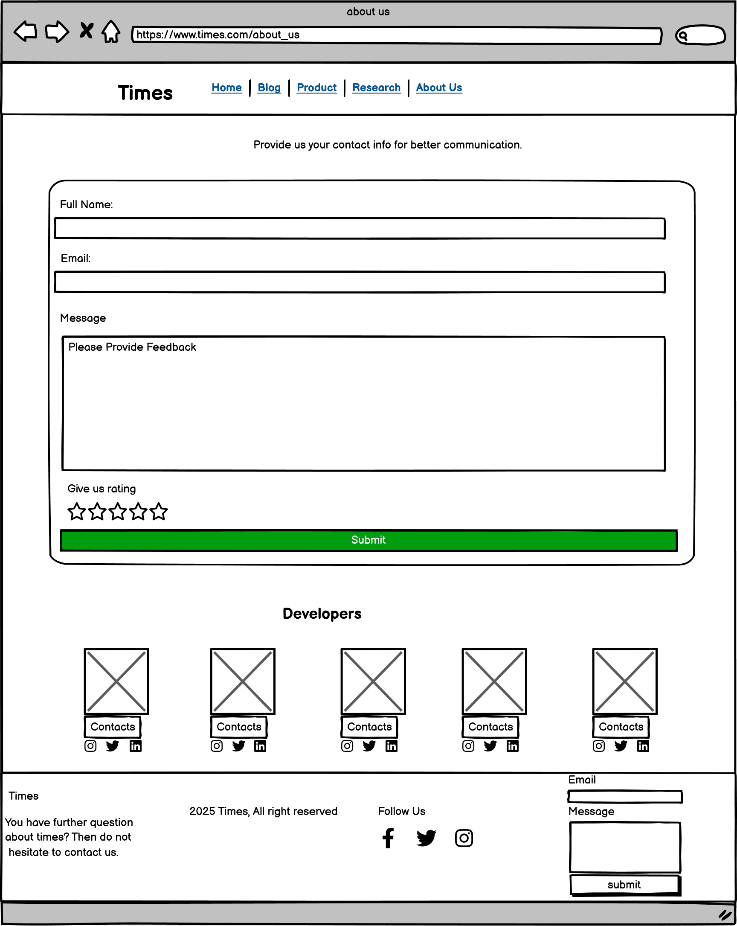

Image 6.9.2

# 7.Source Code

## 7.1 Main CSS code for the webpage layout

*{

    padding: 0;

    margin: 0;

    box-sizing: border-box;

}

body{

    background: #DEF4F6;

}

/* nav section coding starts */

.nav_main_container{

    width: 100%;

    height: auto;

    display: flex;

    justify-content: center;

    position: absolute;

    z-index: +3;

    background:inherit;

}

.nav_container{

    width: 80%;

    height: 75px;

    display: flex;

    padding: 5px 10px;

    background: #1751f4;

    margin-top: 10px;

    border-radius: 15px;

}

.logo{

    width: 20%;

    color: #ffffff;

    font-weight: bolder;

    font-size: 90px;

    display: flex;

    align-items: center;

    margin-left: 15px;

}

.nav_section{

    width: 80%;

}

nav ul{

    list-style: none;

    display: flex;

    width: 100%;

    padding: 20px 0px;

    position: relative;

}

nav ul li a{

    text-align: center;

    padding: 20px 60px;

    text-decoration: none;

    color: #ffffff;

    font-family: 'Ubuntu', sans-serif;

    font-weight: 800;

}

#home a{

    color: black;

    background-color: #ffffff;

    border-radius: 40px 0 40px 0;

    box-shadow: 0 0 10px #ffffff;

    transition: 0.6s ease;

    font-size: 17px;

  }

nav ul li a:hover{

  color: black;

  background-color: #ffffff;

  border-radius: 40px 0 40px 0;

  box-shadow: 0 0 10px #ffffff;

  transition: 0.6s ease;

  font-size: 17px;

}

/*main img slider -----------------------------------------------  */

.main_img{

    width: 100%;

    height: 783px;

    overflow: hidden;

    position: relative;

}

/* Slideshow container */

.slideshow-container {

    max-width: 100%;

    margin: auto;

    padding-top: 10px;

  }

  /* Hide the images by default */

  .mySlides {

    display: none;

  }

  /* Next & previous buttons */

  .prev, .next {

    cursor: pointer;

    position: absolute;

    top: 50%;

    width: auto;

    margin-top: -22px;

    padding: 16px;

    color: white;

    font-weight: bold;

    font-size: 18px;

    transition: 0.6s ease;

    border-radius: 0 3px 3px 0;

    user-select: none;

  }

  /* Position the "next button" to the right */

  .next {

    right: 0;

    border-radius: 3px 0 0 3px;

  }

  /* On hover, add a black background color with a little bit see-through */

  .prev:hover, .next:hover {

    background-color: rgba(0,0,0,0.8);

  }

  /* heightlights container */

  .heighlights{

    display: flex;

    flex-direction: column;

  }

  /* blog section coding starts */

  .blog_highlight_main,.product_highlight_main, .research_highlight_main{

    width: 100%;

    display: flex;

    justify-content: center;

  }

  .blog_highlight_container, .product_highlight_container, .research_highlight_container{

    width: 80%;

  }

  .blog_highlight_section, .research_highlight_section{

    display: flex;

    flex-direction: row;

    width: 100%;

    background: #DEF4F6;

  }

  .blog_highlight_img, .blog_highlight_content, .research_highlight_img, .research_highlight_content{

    width: 50%;

  }

  .product_highlight_main{

    margin-top: 50px;

  }

/* highlight product section coding ------------------------------------------------------------------------------- */

.product_highlight_section{

    width: 100%;

    height: auto;

    background: #DEF4F6;

    padding: 30px;

}

/* Slider Section */

.p_collection_text {

    font-family: "Quicksand", serif;

    font-size: 40px;

    padding: 200px;

    margin-top: 30px;

    color: #167A4E;

}

.p_img_slider {

    display: flex;

    align-items: center;

    justify-content: center;

    min-height: 70px;

    color: #fff;

    padding: 30px;

}

.p_img_slider_container {

    position: relative;

    overflow: hidden;

    width: 80%;

    max-width: 2300px;

    padding: 8px;

}

.p_slider{

    display: flex;

    transition: transform 0.4s ease-in-out;

    gap: 24px;

}

.watch-item {

    min-width: calc(25% - 20px);

    box-sizing: border-box;

    color: rgb(255, 145, 0);

    padding: 50px;

    display: flex;

    flex-direction: column;

    align-items: center;

    justify-content: center;

    backdrop-filter: blur(30px);

    border-radius: 20px;

    background: #8BA4A5;

}

.watch-image {

    width: 200px;

    height: 200px;

    border-radius: 30px;

    object-fit: cover;

    margin-bottom: 15px;

}

.watch-price {

    font-size: 20px;

    color: tan;

    font-weight: 500;

    margin: 10px 0px;

}

/* Buttons for navigation */

#p_prev,

#p_next{

    position: absolute;

    top: 40%;

    width: 50px;

    height: 50px;

    background: #fff;

    border: none;

    border-radius: 50%;

    display: flex;

    align-items: center;

    justify-content: center;

    cursor: pointer;

    opacity: 0.7;

    box-shadow: 0px 2px 5px rgba(0, 0, 0, 0.2);

    transition: opacity 0.3s, transform 0.2s;

}

#p_prev{

    left: 2%;

}

#p_next{

    right: 2%;

}

.button:hover {

    opacity: 1;

    transform: scale(1.1);

}

/* Dots for navigation */

#dots {

    text-align: center;

    margin-top: 10px;

}

.dot {

    display: inline-block;

    width: 40px;

    height: 4px;

    background: #fff;

    border-radius: 10%;

    margin: 5px;

    cursor: pointer;

    opacity: 0.2;

}

.dot.active {

    opacity: 1;

}

/* buy now button------------------------------------------------------------- */

.buyNow {

    text-align: center;

    margin-top: 10px;

    width: 140px;

    height: 40px;

    background: #E5924A;

    border-radius: 5px;

    cursor: pointer;

    border: none;

}

.buyNow:hover {

    background: #d69f6e;

    transition: all 0.3s ease;

    transform: scale(1.03);

    font-size: 16px;

}

.buyNow a{

    text-decoration: none;

    color: white;

    font-size: 16px;

    font-weight: 500;

    margin: 30px;

}

.show-morebtn {

    display: flex;

    justify-content: center;

}

.show-more:hover {

    transform: scale(1.03);

    transition: all 0.3s ease;

    font-size: 15px;

}

/* Hover effect for items */

.watch-item:hover {

    cursor: pointer;

    transform: scale(1.05);

    transition: all 0.7s ease;

}

 /* why us section designing */

.whyus-main-container {

    width: 100%;

    width: auto;

    padding-top: 25px;

    margin-bottom: 30px;

}

.whyus-container{

    width: 100%;

    height: auto;

    display: flex;

    flex-direction: row;

    padding-top: 20px ;

}

.freeShipping,.securePayment,.orderTracking,.easyReturns{

    width: 25%;

    height: auto ;

}

/* Rating star */

.rating :hover{

    color: yellow;

    cursor: pointer;

}

/* footer designing  */

footer{

    width: 100%;

    height: auto;

    background: #1D347A;

    padding: 20px;

    color: white;

    font-family: 'Ubuntu', sans-serif;

}

7.2 Product page CSS Code

*{

    padding: 0;

    margin: 0;

    box-sizing: border-box;

}

/* nav section coding starts --------------------------------------------------------------------------------------------------------- */

.nav_main_container{

    width: 100%;

    height: auto;

    display: flex;

    justify-content: center;

    position: absolute;

    z-index: +3;

    background:inherit;

}

.nav_container{

    width: 80%;

    height: 75px;

    display: flex;

    padding: 5px 10px;

    background: #1751f4;

    margin-top: 10px;

    border-radius: 15px;

}

.logo{

    width: 20%;

    color: #ffffff;

    font-weight: bolder;

    font-size: 90px;

    display: flex;

    align-items: center;

    margin-left: 15px;

}

.nav_section{

    width: 80%;

}

nav ul{

    list-style: none;

    display: flex;

    width: 100%;

    padding: 20px 0px;

    position: relative;

}

nav ul li a{

    text-align: center;

    padding: 20px 60px;

    text-decoration: none;

    color: #ffffff;

    font-family: 'Ubuntu', sans-serif;

    font-weight: 800;

}

#about a{

    color: black;

    background-color: #ffffff;

    border-radius: 40px 0 40px 0;

    box-shadow: 0 0 10px #ffffff;

    transition: 0.6s ease;

    font-size: 17px;

  }

nav ul li a:hover{

  color: black;

  background-color: #ffffff;

  border-radius: 40px 0 40px 0;

  box-shadow: 0 0 10px #ffffff;

  transition: 0.6s ease;

  font-size: 17px;

}

/* about us designing starts */

.aboutUs-main-container{

    width: 100%;

    height: auto;

    display: flex;

    justify-content: center;

    align-items: center;

    padding-top: 100px;

}

.developer-containers{

    width: 80%;

    height: auto;

    padding-left: 90px;

}

#dev-img{

    width: 200px;

    height: auto;

    background: #e9e9e9;

    padding-top: 15px;

}

.developer-containers span{

    font-family: 'Ubuntu', sans-serif;

    color: #545454;

    font-size: 14px;

    font-weight: 400;

}

.developer-containers h3{

    font-family: sans-serif;

    color: #000000;

    font-size: 22px;

    margin: 10px 0;

    margin-bottom: 0;

}

.developer-1-details{

    margin: 5px;

}

.developer-1-2{

    width: 48%;

    height: auto;

    background: #ffffff;

    border-radius: 15px;

    margin-bottom: 20px;

    display: flex;

    flex-direction: row;

}

.developer-3-4-5{

    width: 48%;

    height: auto;

    background: #ffffff;

    border-radius: 15px;

    margin-bottom: 20px;

    display: flex;

    flex-direction: row;

}

/* form validation */

.contact-us{

    width: 80%;

   margin-left:150px;

}

#Form {

    max-width: 100%;

    margin: auto;

    padding: 20px;

    border: 1px solid #ccc;

    border-radius: 10px;

    background-color: #f9f9f9;

}

.form-group {

    margin-bottom: 15px;

}

label {

    display: block;

    margin-bottom: 5px;

}

input {

    width: 100%;

    padding: 8px;

    border: 1px solid #ccc;

    border-radius: 5px;

}

.error {

    color: red;

    font-size: 0.9em;

}

button {

    width: 100%;

    background-color: #4CAF50;

    color: white;

    border: none;

    padding: 10px 15px;

    border-radius: 5px;

    cursor: pointer;

}

button:hover {

    background-color: #45a049;

}

/* footer designing  */

footer{

    width: 100%;

    height: auto;

    background: #1D347A;

    padding: 20px;

    color: white;

    font-family: 'Ubuntu', sans-serif;

}

## 7.3 Blog Page CSS Code

*{

    padding: 0;

    margin: 0;

    box-sizing: border-box;

}

/* nav section coding starts --------------------------------------------------------------------------------------------------------- */

.nav_main_container{

    width: 100%;

    height: auto;

    display: flex;

    justify-content: center;

    position: absolute;

    z-index: +3;

    background:inherit;

}

.nav_container{

    width: 80%;

    height: 75px;

    display: flex;

    padding: 5px 10px;

    background: #1751f4;

    margin-top: 10px;

    border-radius: 15px;

}

.logo{

    width: 20%;

    color: #ffffff;

    font-weight: bolder;

    font-size: 90px;

    display: flex;

    align-items: center;

    margin-left: 15px;

}

.nav_section{

    width: 80%;

}

nav ul{

    list-style: none;

    display: flex;

    width: 100%;

    padding: 20px 0px;

    position: relative;

}

nav ul li a{

    text-align: center;

    padding: 20px 60px;

    text-decoration: none;

    color: #ffffff;

    font-family: 'Ubuntu', sans-serif;

    font-weight: 800;

}

#blog a{

    color: black;

    background-color: #ffffff;

    border-radius: 40px 0 40px 0;

    box-shadow: 0 0 10px #ffffff;

    transition: 0.6s ease;

    font-size: 17px;

  }

nav ul li a:hover{

  color: black;

  background-color: #ffffff;

  border-radius: 40px 0 40px 0;

  box-shadow: 0 0 10px #ffffff;

  transition: 0.6s ease;

  font-size: 17px;

}

/* blog secion design starts ---------------------------------------------------------------------- */

.blog-main-container{

    width: 80%;

    height: auto;

    display: flex;

    justify-content: center;

    padding-top: 120px;

    flex-direction: column;

}

.blog-wlcm-text{

    color: #000000;

    font-size: 50px;

    font-weight: bold;

    margin-bottom: 30px;

}

.blog-one-section{

    display: flex;

    flex-direction: row;

}

.blog-one-img, .blog-one-content{

    width: 50%;

    padding: 20px;

}

.blog-one-content p{

    padding: 5px;

    font-size: 18px;

}

/* read more button */

.readMore-btn{

    display: flex;

    justify-content: center;

    align-items: center;

    margin-bottom: 20px;

}

.readMore{

    width: 140px;

    height: 40px;

    padding: 10px;

    background: #1751f4;

    border: none;

    border-radius: 5px;

    color: white;

}

.readMore a{

    color: white;

    font-weight: 600;

    text-decoration: none;

}

/* blog secion design ends ---------------------------------------------------------------------- */

/* footer designing  */

footer{

    width: 100%;

    height: auto;

    background: #1D347A;

    padding: 20px;

    color: white;

    font-family: 'Ubuntu', sans-serif;

}

## 7.4 Reasearch CSS Code

*{

    padding: 0;

    margin: 0;

    box-sizing: border-box;

}

/* nav section coding starts --------------------------------------------------------------------------------------------------------- */

.nav_main_container{

    width: 100%;

    height: auto;

    display: flex;

    justify-content: center;

    position: absolute;

    z-index: +3;

    background:inherit;

}

.nav_container{

    width: 80%;

    height: 75px;

    display: flex;

    padding: 5px 10px;

    background: #1751f4;

    margin-top: 10px;

    border-radius: 15px;

}

.logo{

    width: 20%;

    color: #ffffff;

    font-weight: bolder;

    font-size: 90px;

    display: flex;

    align-items: center;

    margin-left: 15px;

}

.nav_section{

    width: 80%;

}

nav ul{

    list-style: none;

    display: flex;

    width: 100%;

    padding: 20px 0px;

    position: relative;

}

nav ul li a{

    text-align: center;

    padding: 20px 60px;

    text-decoration: none;

    color: #ffffff;

    font-family: 'Ubuntu', sans-serif;

    font-weight: 800;

}

#research a{

    color: black;

    background-color: #ffffff;

    border-radius: 40px 0 40px 0;

    box-shadow: 0 0 10px #ffffff;

    transition: 0.6s ease;

    font-size: 17px;

  }

nav ul li a:hover{

  color: black;

  background-color: #ffffff;

  border-radius: 40px 0 40px 0;

  box-shadow: 0 0 10px #ffffff;

  transition: 0.6s ease;

  font-size: 17px;

}

/* research section designing */

.research-main-container{

    width: 100%;

    height: auto;

    padding-top: 100px;

    display: flex;

    justify-content: center;

    align-items: center;

}

.research-container{

    width: 80%;

    height: auto;

    padding: 30px;

}

/* footer designing  */

footer{

    width: 100%;

    height: auto;

    background: #1D347A;

    padding: 20px;

    color: white;

    font-family: 'Ubuntu', sans-serif;

}

## 7.5 CV CSS Code

*{

    padding: 0;

    margin: 0;

    box-sizing: border-box;

}

/* nav section coding starts --------------------------------------------------------------------------------------------------------- */

.nav_main_container{

    width: 100%;

    height: auto;

    display: flex;

    justify-content: center;

    position: absolute;

    z-index: +3;

    background:inherit;

}

.nav_container{

    width: 80%;

    height: 75px;

    display: flex;

    padding: 5px 10px;

    background: #1751f4;

    margin-top: 10px;

    border-radius: 15px;

}

.logo{

    width: 20%;

    color: #ffffff;

    font-weight: bolder;

    font-size: 90px;

    display: flex;

    align-items: center;

    margin-left: 15px;

}

.nav_section{

    width: 80%;

}

nav ul{

    list-style: none;

    display: flex;

    width: 100%;

    padding: 20px 0px;

    position: relative;

}

nav ul li a{

    text-align: center;

    padding: 20px 60px;

    text-decoration: none;

    color: #ffffff;

    font-family: 'Ubuntu', sans-serif;

    font-weight: 800;

}

#about a{

    color: black;

    background-color: #ffffff;

    border-radius: 40px 0 40px 0;

    box-shadow: 0 0 10px #ffffff;

    transition: 0.6s ease;

    font-size: 17px;

  }

nav ul li a:hover{

  color: black;

  background-color: #ffffff;

  border-radius: 40px 0 40px 0;

  box-shadow: 0 0 10px #ffffff;

  transition: 0.6s ease;

  font-size: 17px;

}

/* about us designing starts */

.aboutUs-main-container{

    width: 100%;

    height: auto;

    display: flex;

    justify-content: center;

    align-items: center;

    padding-top: 100px;

}

.developer-containers{

    width: 80%;

    height: auto;

    padding-left: 90px;

}

#dev-img{

    width: 200px;

    height: auto;

    background: #e9e9e9;

    padding-top: 15px;

}

.developer-containers span{

    font-family: 'Ubuntu', sans-serif;

    color: #545454;

    font-size: 14px;

    font-weight: 400;

}

.developer-containers h3{

    font-family: sans-serif;

    color: #000000;

    font-size: 22px;

    margin: 10px 0;

    margin-bottom: 0;

}

.developer-1-details{

    margin: 5px;

}

.developer-1-2{

    width: 48%;

    height: auto;

    background: #ffffff;

    border-radius: 15px;

    margin-bottom: 20px;

    display: flex;

    flex-direction: row;

}

.developer-3-4-5{

    width: 48%;

    height: auto;

    background: #ffffff;

    border-radius: 15px;

    margin-bottom: 20px;

    display: flex;

    flex-direction: row;

}

/* form validation */

.contact-us{

    width: 80%;

   margin-left:150px;

}

#Form {

    max-width: 100%;

    margin: auto;

    padding: 20px;

    border: 1px solid #ccc;

    border-radius: 10px;

    background-color: #f9f9f9;

}

.form-group {

    margin-bottom: 15px;

}

label {

    display: block;

    margin-bottom: 5px;

}

input {

    width: 100%;

    padding: 8px;

    border: 1px solid #ccc;

    border-radius: 5px;

}

.error {

    color: red;

    font-size: 0.9em;

}

button {

    width: 100%;

    background-color: #4CAF50;

    color: white;

    border: none;

    padding: 10px 15px;

    border-radius: 5px;

    cursor: pointer;

}

button:hover {

    background-color: #45a049;

}

/* footer designing  */

footer{

    width: 100%;

    height: auto;

    background: #1D347A;

    padding: 20px;

    color: white;

    font-family: 'Ubuntu', sans-serif;

}

## 7.6 Java Script Code for image slider (Men’s Collection)

/*JS code for image slider*/

const slider = document.querySelector('.slider');

const prev = document.getElementById('prev');

const next = document.getElementById('next');

const dotsContainer = document.getElementById('dots');

const items = document.querySelectorAll('.watch-item');

/*Code to show number of pictures per slide*/

const itemsPerView = 4;

let currentIndex = 0;

/*Code to show total number of pictures*/

const totalItems = items.length;

const totalViews = totalItems - itemsPerView + 1;

/*To create dots based on the number of images*/

for (let i = 0; i < totalViews; i++) {

  const dot = document.createElement('div');

  dot.classList.add('dot');

  dot.onclick = () => showView(i);

  dotsContainer.appendChild(dot);

}

/*to show atleast one dot*/

const dots = document.querySelectorAll('.dot');

dots[0].classList.add('active');

/*To hide and show the previous and next buttons*/

function updateButtons() {

  prev.style.display = (currentIndex > 0) ? 'flex' : 'none';

  next.style.display = (currentIndex < totalViews - 1) ? 'flex' : 'none';

}

/* Show a specific view based on the index*/

function showView(index) {

  if (index >= totalViews || index < 0) {

    return;  /*Ignore out of range indexes*/

  }

  /*Update the current index and sliding the image based on itemsPerviw*/

  currentIndex = index;

  slider.style.transform = `translateX(${-currentIndex * (100 / itemsPerView)}%)`;

 /*To highligh the active dot */

  dots.forEach(dot => dot.classList.remove('active'));

  dots[currentIndex].classList.add('active');

  updateButtons();

}

/*To show the previous and next images when the button's are pressed*/

prev.onclick = () => showView(currentIndex - 1);

next.onclick = () => showView(currentIndex + 1);

/*Initialize slider view*/

showView(0);

updateButtons();

7.7 JavaScript Code for image slider(Women’s collection)

// Image slider buttons for the second slider

const slider2 = document.querySelector('#slider2');

const prev2 = document.getElementById('prev2');

const next2 = document.getElementById('next2');

const dotsContainer2 = document.getElementById('dots2');

const items2 = slider2.querySelectorAll('.watch-item');

const itemsPerView2 = 4;

let currentIndex2 = 0;

const totalItems2 = items2.length;

const totalViews2 = totalItems2 - itemsPerView2 + 1;

// Create dots for the second slider

for (let i = 0; i < totalViews2; i++) {

    const dot = document.createElement('div');

    dot.classList.add('dot');

    dot.onclick = () => showView2(i);

    dotsContainer2.appendChild(dot);

}

const dots2 = dotsContainer2.querySelectorAll('.dot');

dots2[0].classList.add('active');

function updateButtons2() {

    prev2.style.display = (currentIndex2 > 0) ? 'flex' : 'none';

    next2.style.display = (currentIndex2 < totalViews2 - 1) ? 'flex' : 'none';

}

function showView2(index) {

    if (index >= totalViews2 || index < 0) {

        return;

    }

    currentIndex2 = index;

    slider2.style.transform = `translateX(${-currentIndex2 * (100 / itemsPerView2)}%)`;

    dots2.forEach(dot => dot.classList.remove('active'));

    dots2[currentIndex2].classList.add('active');

    updateButtons2();

}

prev2.onclick = () => showView2(currentIndex2 - 1);

next2.onclick = () => showView2(currentIndex2 + 1);

showView2(0);

updateButtons2();

## 7.8 Home Page HTML

<!DOCTYPE html>

<html lang="en">

<head>

    <meta charset="UTF-8">

    <meta name="viewport" content="width=device-width, initial-scale=1.0">

    <title>Times</title>

    <link rel="stylesheet" href="css/style.css">

    <style>

        .slogan_container {

            position: absolute;

            width: 100%;

            height: 100vh;

            display: flex;

            justify-content: center;

            align-items: center;

            padding-left: 550px;

        }

        .logo {

            cursor: pointer;

            color: white;

        }

        .slogan-text {

            text-decoration: none;

            font-size: 80px;

            color: black;

            text-align: center;

            text-shadow: 0px 5px 5px black;

            font-weight: 400;

        }

        /* nav section coding starts */

.nav_main_container{

    width: 100%;

    height: auto;

    display: flex;

    justify-content: center;

    position: absolute;

    z-index: +3;

    background:inherit;

}

.nav_container{

    width: 80%;

    height: 75px;

    display: flex;

    padding: 5px 10px;

    background: #1751f4;

    margin-top: 10px;

    border-radius: 15px;

}

.logo{

    width: 20%;

    color: #ffffff;

    font-weight: bolder;

    font-size: 90px;

    display: flex;

    align-items: center;

    margin-left: 15px;

}

.nav_section{

    width: 80%;

}

nav ul{

    list-style: none;

    display: flex;

    width: 100%;

    padding: 20px 0px;

    position: relative;

}

nav ul li a{

    text-align: center;

    padding: 20px 60px;

    text-decoration: none;

    color: #ffffff;

    font-family: 'Ubuntu', sans-serif;

    font-weight: 800;

}

#home a{

    color: black;

    background-color: #ffffff;

    border-radius: 40px 0 40px 0;

    box-shadow: 0 0 10px #ffffff;

    transition: 0.6s ease;

    font-size: 17px;

  }

nav ul li a:hover{

  color: black;

  background-color: #ffffff;

  border-radius: 40px 0 40px 0;

  box-shadow: 0 0 10px #ffffff;

  transition: 0.6s ease;

  font-size: 17px;

}

    </style>

</head>

<body>

    <header>

        <!-- nav bar coding starts----------------------------------------------------------------------------------------------- -->

        <div class="nav_main_container">

            <div class="nav_container">

                <div class="logo">

                    <h1 style="font-family: 'Ubuntu', sans-serif; font-size: 35px;">Times</h1>

                </div>

                <nav class="nav_section">

                    <ul style="margin-top: 2px;">

                        <li id="home"><a href="#">Home</a></li>

                        <li id="blog"><a href="pages/blog/blog.html">Blog</a></li>

                        <li id="product"><a href="pages/product/product.html">Products</a></li>

                        <li id="research"><a href="pages/research/research.html">Research</a></li>

                        <li id="about"><a href="pages/about/about.html">About Us</a></li>

                    </ul>

                </nav>

            </div>

        </div>

        <!-- nav bar coding ends ------------------------------------------------------------------------------------------------ -->

    </header>

    <section>

        <!-- Slogan text coding starts------------------------------------------------------------------------------------------- -->

        <div class="slogan_container">

            <h1 class="slogan-text">

                <span>Lost </span> <span style="font-style: italic; color: #1751f4; font-weight: 600;">Time</span>

                <span>Is </span>, <br> Never Found Again.

            </h1>

        </div>

        <!-- Slogan text coding starts------------------------------------------------------------------------------------------- -->

        <!-- section feature image slider coding starts -------------------------------------------------------------------------------- -->

        <div class="main_img" style="padding-top: 15px;">

            <!-- Slideshow container -->

            <div class="slideshow-container">

                <!-- Full-width images with number and caption text -->

                <div class="mySlides fade">

                    <img src="images/1.png" style="width:50%">

                </div>

                <div class="mySlides fade">

                    <img src="images/3.png" style="width:50%">

                </div>

                <div class="mySlides fade">

                    <img src="images/4.png" style="width:50%">

                </div>

                <div class="mySlides fade">

                    <img src="images/2.png" style="width:50%">

                </div>

                <div class="mySlides fade">

                    <img src="images/7.png" style="width:50%">

                </div>

                <div class="mySlides fade">

                    <img src="images/5.png" style="width:50%">

                </div>

                <div class="mySlides fade">

                    <img src="images/8.png" style="width:50%">

                </div>

                <!-- Next and previous buttons -->

                <a class="prev" style="z-index: +1;" onclick="plusSlides(-1)">&#10094;</a>

                <a class="next" style="z-index: +1;" onclick="plusSlides(1)">&#10095;</a>

            </div>

            <br>

        </div>

        <!-- section feature image slider coding ends -------------------------------------------------------------------------------- -->

        <!-- section product highlight coding starts------------------------------------------------------------------------------------------- -->

        <div class="product_highlight_main">

            <div class="product_highlight_container">

                <h1 align="center" style="font-family: 'Ubuntu', sans-serif; font-size: 40px; margin: 50px; color: #167A4E;">

                    PRODUCTS</h1>

                <div class="product_highlight_section">

                    <span class="p_collection_text">Weekly Discounts</span>

                    <p style="margin:20px 200px 0px ; color: #4ecc95; font-family: 'Ubuntu', sans-serif;">Grab your favourite watch before you lose it.</p>

                    <div class="p_img_slider">

                        <div class="p_img_slider_container">

                            <div class="p_slider">

                                <div class="watch-item"><img src="images/1.png" alt="Rolex" class="watch-image">

                                    <h2 class="watch-name">Rolex</h2>

                                    <p class="watch-price"><S>$10,0000</S></p>

                                    <p class="watch-discount-price"> $9,000</p>

                                </div>

                                <div class="watch-item"><img src="images/2.png" alt="Rolex" class="watch-image">

                                    <h2 class="watch-name">Rolex</h2>

                                    <p class="watch-price"><S>$10,0000</S></p>

                                    <p class="watch-discount-price"> $9,000</p>

                                </div>

                                <div class="watch-item"><img src="images/3.png" alt="Rolex" class="watch-image">

                                    <h2 class="watch-name">Rolex</h2>

                                    <p class="watch-price"><S>$10,0000</S></p>

                                    <p class="watch-discount-price"> $9,000</p>

                                </div>

                                <div class="watch-item"><img src="images/4.png" alt="Rolex" class="watch-image">

                                    <h2 class="watch-name">Rolex</h2>

                                    <p class="watch-price"><S>$10,0000</S></p>

                                    <p class="watch-discount-price"> $9,000</p>

                                </div>

                                <div class="watch-item"><img src="images/5.png" alt="Rolex" class="watch-image">

                                    <h2 class="watch-name">Rolex</h2>

                                    <p class="watch-price"><S>$10,0000</S></p>

                                    <p class="watch-discount-price"> $9,000</p>

                                </div>

                                <div class="watch-item"><img src="images/6.png" alt="Rolex" class="watch-image">

                                    <h2 class="watch-name">Rolex</h2>

                                    <p class="watch-price"><S>$10,0000</S></p>

                                    <p class="watch-discount-price"> $9,000</p>

                                </div>

                                <div class="watch-item"><img src="images/7.png" alt="Rolex" class="watch-image">

                                    <h2 class="watch-name">Rolex</h2>

                                    <p class="watch-price"><S>$10,0000</S></p>

                                    <p class="watch-discount-price"> $9,000</p>

                                </div>

                                <div class="watch-item"><img src="images/8.png" alt="Rolex" class="watch-image">

                                    <h2 class="watch-name">Rolex</h2>

                                    <p class="watch-price"><S>$10,0000</S></p>

                                    <p class="watch-discount-price"> $9,000</p>

                                </div>

                            </div>

                            <div class="buttons">

                                <button class="button" id="p_prev">&lt;</button>

                                <button class="button" id="p_next">&gt;</button>

                            </div>

                            <div id="dots"></div>

                            <div class="show-morebtn">

                                <button class="buyNow"><a href="pages/product/product.html">Buy Now</a></button>

                            </div>

                        </div>

                    </div>

                </div>

            </div>

        </div>

        <!-- section product highlight coding ends------------------------------------------------------------------------------------------- -->

        <!-- highlight sections starts ------------------------------------------------------------------------------------------------ -->

        <div class="highlights">

            <!-- section blog highlight coding starts------------------------------------------------------------------------------------------- -->

            <div class="blog_highlight_main">

                <div class="blog_highlight_container">

                    <h1 align="center" style="font-family: 'Ubuntu', sans-serif; font-size: 40px; margin: 50px; color: #167A4E;">BLOG

                    </h1>

                    <div class="blog_highlight_section">

                        <div class="blog_highlight_img">

                            <img src="pages/blog/images/1647354547978.png" alt="Blog 1" width="600px">

                        </div>

                        <div class="blog_highlight_content">

                            <h2>Exploring the impact of technology on the watch industry and consumer trends.</h2>

                            <p style="padding: 5px; font-size: 18px;">The smart watch and smartphone have finnaly achieved a sumbiotic realtionship, with devices like the Apple Watch and Samsung Galaxy delivering notifications, calls, and apps right on the wrist. <br><br>

                            Health and Fitness Monitoring: These gadgets have features like a heart-rate monitoring, sleep tracker, and step counter. Little wonder, therefore, tehat the latest health and fitness smartwatches become the best gadgets for health enthusiasts

                            <br><br>

                            The ability to change watch faces and dtraps to one's own taste or those redommended by a stylist.

                            E-comerce and online Sales. <br>

                            The watch industry is also becoming increasingly popular among women, with women's brands like G-Shine, Meizu, and Garmin offering smartwatches to women.

                            </p>

                        </div>

                    </div>

                    <div style="width: 100%;display: flex; justify-content: center; margin: 20px 0px;">

                        <button class="buyNow"><a href="pages/blog/blog.html">Read More</a></button>

                    </div>

                </div>

            </div>

            <!-- section blog highlight coding ends------------------------------------------------------------------------------------------- -->

            <!-- section research highlight coding starts------------------------------------------------------------------------------------------- -->

            <div class="research_highlight_main">

                <div class="research_highlight_container">

                    <h1 align="center" style="font-family: 'Ubuntu', sans-serif; font-size: 40px; margin: 50px; color: #167A4E;">

                        RESEARCH</h1>

                    <div class="research_highlight_section">

                        <div class="research_highlight_content">

                            <h2>Title 1</h2>

                            <p>Lorem ipsum dolor sit amet, consectetur adipiscing elit. Quisque viverra, arcu eu

                                bibendum ullamcorper, nisi arcu auctor sapien, in bibendum felis arcu non orci. Sed

                                in dui et lectus convallis tristique. Nullam euismod, justo eu consectetur

                                fermentum, lectus massa ullamcorper justo, ut consectetur metus dolor vel ipsum.</p>

                        </div>

                        <div class="research_highlight_img">

                            <img src="pages/research/images/blog.png" alt="Research 1" width="600px">

                        </div>

                    </div>

                    <div style="width: 100%;display: flex; justify-content: center; margin: 20px 0px;">

                        <button class="buyNow"><a href="pages/research/research.html">Show</a></button>

                    </div>

                </div>

            </div>

            <!-- section research highlight coding ends------------------------------------------------------------------------------------------- -->

        </div>

        <!-- highlight sections ends ------------------------------------------------------------------------------------------------ -->

        <!-- section why us starts -------------------------------------------------------------------------------------------------------------------- -->

        <div class="whyus-main-container">

            <h1 id="whyus-text" align="center" style="margin: 30px;">Why choose us?</h1>

            <div class="whyus-container">

                <div class="freeShipping" style="margin-left: 50px;">

                    <img src="icons/shipping.png" alt=""> <br>

                    <h3 style="font-family: 'Ubuntu', sans-serif;">Free Shipping</h3> <br>

                    <p style="font-family: Arial, Helvetica, sans-serif; color: #8d8d8d;">Delight in seamless free

                        shipping, <br>

                        enhancing your shopping experiencnce. <br>

                        Navigate our diverse collection, where <br>

                        cost saving meet product joy.</p>

                </div>

                <div class="securePayment">

                    <img src="icons/secure.png" alt="" style="width: 50px;"> <br>

                    <h3 style="font-family: 'Ubuntu', sans-serif;">Secure Payment</h3> <br>

                    <p style="font-family: Arial, Helvetica, sans-serif; color: #8d8d8d;">Shop with confidence using our

                        secure <br>

                        paymnt mehtods. Your transaction are <br>

                        protected, providing peace of mind for <br>

                        a worry-free shopping.</p>

                </div>

                <div class="orderTracking">

                    <img src="icons/tracking.png" alt=""> <br>

                    <h3 style="font-family: 'Ubuntu', sans-serif;">Order Tracking</h3> <br>

                    <p style="font-family: Arial, Helvetica, sans-serif; color: #8d8d8d;">Tracking your order

                        effortlessly with our <br>stramlined system. Stay informed

                        and <br> in controll as your purchase make its <br> way to your doorstep

                    </p>

                </div>

                <div class="easyReturns">

                    <img src="icons/return.png" alt=""> <br>

                    <h3 style="font-family: 'Ubuntu', sans-serif;">Easy Returns</h3> <br>

                    <p style="font-family: Arial, Helvetica, sans-serif; color: #8d8d8d;">Celebrate worry-free shopping

                        with our <br>

                        hassle-free returns - because we're <br>

                        here to make your shopping experience <br>

                        as smooth as possibel.</p>

                </div>

            </div>

        </div>

        <!-- section why us ends -------------------------------------------------------------------------------------------------------------------- -->

    </section>

    <!-- footer starts -------------------------------------------------------------------------------------------------------------------- -->

    <footer style="width: 100%; display: flex; justify-content: row; padding-top: 40px;">

        <div class="times-footer" style="width: 25%;">

            <h1>Times</h1>

            <p style="margin-top: 20px;">You have further questions about Times? Then do not hesitate to contact us.</p>

        </div>

        <div style="width: 25%;">

            <p style="margin:  55px 50px ;"> 2025 Times . All rights reserved.</p>

        </div>

        <div class="social_media" style="width: 25%;">

            <p style="font-family: 'Ubuntu', sans-serif; margin: 5px 10px; margin-bottom: 15px;">Follow us</p>

            <a href="#"><img src="icons/facebook.png" alt="Facebook" width="60px"></a>

            <a href="#"><img src="icons/x.png" alt="Twitter" width="60px"></a>

            <a href="#"><img src="icons/instagram.png" alt="Instagram" width="60px"></a>

        </div>

        <div class="contact_info" style="width: 25%; font-family: 'Ubuntu', sans-serif;">

            <form>

                <span>Email</span><br>

                <input type="number" placeholder="Enter your email"

                    style="padding: 5px; width: 350px; margin: 10px 0;"><br>

                <span>Messaage</span><br>

                <textarea name="message" id="message"

                    style="padding: 5px; width: 350px; height: 60px; margin: 10px 0;"></textarea><br>

                <input type="submit" placeholder="submit"

                    style="width: 350px; height: 40px; font-size: 18px; background: rgb(235, 58, 58); border: none; border-radius: 5px;">

            </form>

        </div>

    </footer>

    <!-- footer ends --------------------------------------------------------------------------------------------------------------------- -->

    <script src="js/index.js">

    </script>

</body>

</html>

## 7.9 Blog Page

<!DOCTYPE html>

<html lang="en">

<head>

    <meta charset="UTF-8">

    <meta name="viewport" content="width=device-width, initial-scale=1.0">

    <title>Times | blog</title>

    <link rel="stylesheet" href="css/style.css">

    <style>

        .logo {

            cursor: pointer;

            color: #ffffff;

        }

    </style>

</head>

<body>

    <header>

        <!-- nav bar coding starts----------------------------------------------------------------------------------------------- -->

        <div class="nav_main_container">

            <div class="nav_container">

                <div class="logo">

                    <h1 style="font-family: 'Ubuntu', sans-serif; font-size: 35px;">Times</h1>

                </div>

                <nav class="nav_section">

                    <ul style="margin-top: 2px;">

                        <li id="home"><a href="../../index.html">Home</a></li>

                        <li id="blog"><a href="#">Blog</a></li>

                        <li id="product"><a href="../product/product.html">Products</a></li>

                        <li id="research"><a href="../research/research.html">Research</a></li>

                        <li id="about"><a href="../about/about.html">About Us</a></li>

                    </ul>

                </nav>

            </div>

        </div>

        <!-- nav bar coding ends ------------------------------------------------------------------------------------------------ -->

    </header>

    <section>

        <div style="display: flex; justify-content: center;">

            <div class="blog-main-container">

                <h1 class="blog-wlcm-text" align="center">Welcome to the blog of Times</h1>

                <div class="blog-section">

                    <div class="blog-one-section">

                        <div class="blog-one-img">

                            <img src="images/1647354547978.png" alt="Blog 1" width="600px">

                        </div>

                        <div class="blog-one-content">

                            <h2>Exploring the impact of technology on the watch industry and consumer trends.</h2>

                            <p>The smart watch and smartphone have finnaly achieved a sumbiotic realtionship, with devices like the Apple Watch and Samsung Galaxy delivering notifications, calls, and apps right on the wrist. <br><br>

                            Health and Fitness Monitoring: These gadgets have features like a heart-rate monitoring, sleep tracker, and step counter. Little wonder, therefore, tehat the latest health and fitness smartwatches become the best gadgets for health enthusiasts

                            <br><br>

                            The ability to change watch faces and dtraps to one's own taste or those redommended by a stylist.

                            E-comerce and online Sales. <br>

                            The watch industry is also becoming increasingly popular among women, with women's brands like G-Shine, Meizu, and Garmin offering smartwatches to women.

                            </p>

                        </div>

                    </div>

                    <div class="readMore-btn">

                        <button class="readMore" align="center"><a href="blog_pages/blog-one/blog-one.html">Read More</a></button>

                    </div>

                </div>

                <div class="blog-section">

                    <div class="blog-one-section">

                        <div class="blog-one-content">

                            <h2>Technological advancements with watch design and sales.</h2>

                            <p>There are various relevant topics that integrate technological advancements with watch design and sales.

                                1. Smartwatches and wearable tech <br>

                                Modern technologies have merged themselves with traditional watch designs. Smartwatches do more than just tell time.

                                <br><br>Health Monitoring: The smartwatch can track the rate of one's heart, sleeping patterns, steps, and even falls general value addition for health and fitness enthusiasts.

                                <br><br>

                                Sustainable materials: Using eco-friendly materials in watch manufacturing.

                                <br><br>

                                Connectivity: It syncs with a smartphone to allow wrist notifications of calls and messages, along with some app features.

                            </p>

                        </div>

                        <div class="blog_highlight_img">

                            <img src="images/Wearable-technology-in-healthcare.jpg" alt="Blog 1" width="600px">

                        </div>

                    </div>

                    <div class="readMore-btn">

                        <button class="readMore" align="center" style="margin-top: 20px;"><a href="blog_pages/blog-two/blog-two.html">Read More</a></button>

                    </div>

                </div>

            </div>

        </div>

    </section>

    <!-- footer starts -------------------------------------------------------------------------------------------------------------------- -->

    <footer style="width: 100%; display: flex; justify-content: row; padding-top: 40px;">

        <div class="times-footer" style="width: 25%;">

            <h1>Times</h1>

            <p style="margin-top: 20px;">You have further questions about Times? Then do not hesitate to contact us.</p>

        </div>

        <div style="width: 25%;">

            <p style="margin:  55px 50px ;"> 2025 Times . All rights reserved.</p>

        </div>

        <div class="social_media" style="width: 25%;">

            <p style="font-family: 'Ubuntu', sans-serif; margin: 5px 10px; margin-bottom: 15px;">Follow us</p>

            <a href="#"><img src="../../icons/facebook.png" alt="Facebook" width="60px"></a>

            <a href="#"><img src="../../icons/x.png" alt="Twitter" width="60px"></a>

            <a href="#"><img src="../../icons/instagram.png" alt="Instagram" width="60px"></a>

        </div>

        <div class="contact_info" style="width: 25%; font-family: 'Ubuntu', sans-serif;">

            <form>

                <span>Email</span><br>

                <input type="number" placeholder="Enter your email"

                    style="padding: 5px; width: 350px; margin: 10px 0;"><br>

                <span>Messaage</span><br>

                <textarea name="message" id="message"

                    style="padding: 5px; width: 350px; height: 60px; margin: 10px 0;"></textarea><br>

                <input type="submit" placeholder="submit"

                    style="width: 350px; height: 40px; font-size: 18px; background: rgb(235, 58, 58); border: none; border-radius: 5px;">

            </form>

        </div>

    </footer>

    <!-- footer ends --------------------------------------------------------------------------------------------------------------------- -->

</body>

</html>

### 7.8.1 Blog page

<!DOCTYPE html>

<html lang="en">

<head>

    <meta charset="UTF-8">

    <meta name="viewport" content="width=device-width, initial-scale=1.0">

    <title>Times | blog</title>

    <style>

*{

    padding: 0;

    margin: 0;

    box-sizing: border-box;

}

/* nav section coding starts --------------------------------------------------------------------------------------------------------- */

.nav_main_container{

    width: 100%;

    height: auto;

    display: flex;

    justify-content: center;

    position: absolute;

    z-index: +3;

    background:inherit;

}

.nav_container{

    width: 80%;

    height: 75px;

    display: flex;

    padding: 5px 10px;

    background: #1751f4;

    margin-top: 10px;

    border-radius: 15px;

}

.logo{

    width: 20%;

    color: #ffffff;

    font-weight: bolder;

    font-size: 90px;

    display: flex;

    align-items: center;

    margin-left: 15px;

}

.nav_section{

    width: 80%;

}

nav ul{

    list-style: none;

    display: flex;

    width: 100%;

    padding: 20px 0px;

    position: relative;

}

nav ul li a{

    text-align: center;

    padding: 20px 60px;

    text-decoration: none;

    color: #ffffff;

    font-family: 'Ubuntu', sans-serif;

    font-weight: 800;

}

#blog a{

    color: black;

    background-color: #ffffff;

    border-radius: 40px 0 40px 0;

    box-shadow: 0 0 10px #ffffff;

    transition: 0.6s ease;

    font-size: 17px;

  }

nav ul li a:hover{

  color: black;

  background-color: #ffffff;

  border-radius: 40px 0 40px 0;

  box-shadow: 0 0 10px #ffffff;

  transition: 0.6s ease;

  font-size: 17px;

}

/* blog secion design starts ---------------------------------------------------------------------- */

.blog-main-container{

    width: 80%;

    height: auto;

    display: flex;

    justify-content: center;

    padding-top: 120px;

    flex-direction: column;

}

.blog-wlcm-text{

    color: #000000;

    font-size: 50px;

    font-weight: bold;

    margin-bottom: 30px;

}

.blog-one-section{

    display: flex;

    flex-direction: row;

}

.blog-one-img, .blog-one-content{

    width: 50%;

    padding: 20px;

}

.blog-section p{

    padding: 5px;

    font-size: 18px;

}

/* read more button */

.readMore-btn{

    display: flex;

    justify-content: center;

    align-items: center;

    margin-bottom: 20px;

}

.readMore{

    width: 140px;

    height: 40px;

    padding: 10px;

    background: #1751f4;

    border: none;

    border-radius: 5px;

    color: white;

}

.readMore a{

    color: white;

    font-weight: 600;

    text-decoration: none;

}

/* blog secion design ends ---------------------------------------------------------------------- */

/* footer designing  */

footer{

    width: 100%;

    height: auto;

    background: #1D347A;

    padding: 20px;

    color: white;

    font-family: 'Ubuntu', sans-serif;

}

    </style>

</head>

<body>

    <header>

        <!-- nav bar coding starts----------------------------------------------------------------------------------------------- -->

        <div class="nav_main_container">

            <div class="nav_container">

                <div class="logo">

                    <h1 style="font-family: 'Ubuntu', sans-serif; font-size: 35px;">Times</h1>

                </div>

                <nav class="nav_section">

                    <ul style="margin-top: 2px;">

                        <li id="home"><a href="../../../../index.html">Home</a></li>

                        <li id="blog"><a href="../../blog.html">Blog</a></li>

                        <li id="product"><a href="../../../product/product.html">Products</a></li>

                        <li id="research"><a href="../../../research/research.html">Research</a></li>

                        <li id="about"><a href="../../../about/about.html">About Us</a></li>

                    </ul>

                </nav>

            </div>

        </div>

        <!-- nav bar coding ends ------------------------------------------------------------------------------------------------ -->

    </header>

    <section>

        <div style="display: flex; justify-content: center;">

            <div class="blog-main-container">

                <h1 class="blog-wlcm-text" align="center">Welcome to the blog of Times</h1>

                <div class="blog-section">

                    <div class="blog-one-section">

                        <div class="blog-one-img">

                            <img src="../../images//1647354547978.png" alt="Blog 1" width="600px">

                            <img src="../../images/v2-7rqmc-27xxc.jpg" alt="blog 1" width="600px" style="padding-top: 50px;">

                        </div>

                        <div class="blog-one-content">

                            <h2>Exploring the impact of technology on the watch industry and consumer trends.</h2>

                            <p>The smart watch and smartphone have finnaly achieved a sumbiotic realtionship, with devices like the Apple Watch and Samsung Galaxy delivering notifications, calls, and apps right on the wrist. <br><br>

                            Health and Fitness Monitoring: These gadgets have features like a heart-rate monitoring, sleep tracker, and step counter. Little wonder, therefore, tehat the latest health and fitness smartwatches become the best gadgets for health enthusiasts

                            <br><br>

                            The ability to change watch faces and dtraps to one's own taste or those redommended by a stylist.

                            E-comerce and online Sales. <br>

                            The watch industry is also becoming increasingly popular among women, with women's brands like G-Shine, Meizu, and Garmin offering smartwatches to women.

                            Online Marketplaces: this includes Amazon, eBay, and others

                            selling timepieces and accessories; they have all streamlined

                            the process that a customer goes through before they purchase

                            a watch to something as easy as a mouse click. <br><br>

                            Virtual Try-Ons: Augmented Reality technology gives

                            consumers an opportunity to try a watch on virtually through

                            their smartphones and, therefore, enhances their shopping

                            experience. <br><br>

                            Wearable Technology: In the market of wearable technology

                            it also uses breakthrough materials such as ceramics, carbon

                            fibers, and titanium for a lightweight and sturdy quality to the

                            product. <br><br>

                            Solar Power and Kinetic Energy:

                            Now, some brands of watches operate on solar power or kinetic

                            energy and hence do not call for changing batteries, making

                            them important to green consumers. <br><br>

                            Data and Analytics:

                            Insight on the Consumer: By using Data Analytics, brands are

                            gaining insights into the choices and behavior of the customer,

                            hence providing the right product for the market need

                            Personalized Marketing: In this regard, digital marketing

                            harmonizes with all these technologies through customer

                            behavior and preferences to inform right marketing strategies.

                            </p>

                        </div>

                    </div>

                    <!-- <div class="readMore-btn">

                        <button class="readMore" align="center"><a href="blog-one/blog-one.html">Read More</a></button>

                    </div> -->

                </div>

            </div>

        </div>

    </section>

    <!-- footer starts -------------------------------------------------------------------------------------------------------------------- -->

    <footer style="width: 100%; display: flex; justify-content: row; padding-top: 40px;">

        <div class="times-footer" style="width: 25%;">

            <h1>Times</h1>

            <p style="margin-top: 20px;">You have further questions about Times? Then do not hesitate to contact us.</p>

        </div>

        <div style="width: 25%;">

            <p style="margin:  55px 50px ;"> 2025 Times . All rights reserved.</p>

        </div>

        <div class="social_media" style="width: 25%;">

            <p style="font-family: 'Ubuntu', sans-serif; margin: 5px 10px; margin-bottom: 15px;">Follow us</p>

            <a href="#"><img src="../../../../../../icons/facebook.png" alt="Facebook" width="60px"></a>

            <a href="#"><img src="../../../../../../icons/x.png" alt="Twitter" width="60px"></a>

            <a href="#"><img src="../../../../../../icons/instagram.png" alt="Instagram" width="60px"></a>

        </div>

        <div class="contact_info" style="width: 25%; font-family: 'Ubuntu', sans-serif;">

            <form>

                <span>Email</span><br>

                <input type="number" placeholder="Enter your email"

                    style="padding: 5px; width: 350px; margin: 10px 0;"><br>

                <span>Messaage</span><br>

                <textarea name="message" id="message"

                    style="padding: 5px; width: 350px; height: 60px; margin: 10px 0;"></textarea><br>

                <input type="submit" placeholder="submit"

                    style="width: 350px; height: 40px; font-size: 18px; background: rgb(235, 58, 58); border: none; border-radius: 5px;">

            </form>

        </div>

    </footer>

    <!-- footer ends --------------------------------------------------------------------------------------------------------------------- -->

</body>

</html>

### 7.8.2 Blog Page 2

<!DOCTYPE html>

<html lang="en">

<head>

    <meta charset="UTF-8">

    <meta name="viewport" content="width=device-width, initial-scale=1.0">

    <title>Times | blog</title>

    <link rel="stylesheet" href="css/style.css">

    <style>

        *{

            padding: 0;

            margin: 0;

            box-sizing: border-box;

        }

        /* nav section coding starts --------------------------------------------------------------------------------------------------------- */

        .nav_main_container {

            width: 100%;

            height: auto;

            display: flex;

            justify-content: center;

            position: absolute;

            z-index: +3;

            background: inherit;

        }

        .nav_container {

            width: 80%;

            height: 75px;

            display: flex;

            padding: 5px 10px;

            background: #1751f4;

            margin-top: 10px;

            border-radius: 15px;

        }

        .logo {

            width: 20%;

            color: #ffffff;

            font-weight: bolder;

            font-size: 90px;

            display: flex;

            align-items: center;

            margin-left: 15px;

        }

        .nav_section {

            width: 80%;

        }

        nav ul {

            list-style: none;

            display: flex;

            width: 100%;

            padding: 20px 0px;

            position: relative;

        }

        nav ul li a {

            text-align: center;

            padding: 20px 60px;

            text-decoration: none;

            color: #ffffff;

            font-family: 'Ubuntu', sans-serif;

            font-weight: 800;

        }

        #blog a {

            color: black;

            background-color: #ffffff;

            border-radius: 40px 0 40px 0;

            box-shadow: 0 0 10px #ffffff;

            transition: 0.6s ease;

            font-size: 17px;

        }

        nav ul li a:hover {

            color: black;

            background-color: #ffffff;

            border-radius: 40px 0 40px 0;

            box-shadow: 0 0 10px #ffffff;

            transition: 0.6s ease;

            font-size: 17px;

        }

        /* blog secion design starts ---------------------------------------------------------------------- */

        .blog-main-container {

            width: 80%;

            height: auto;

            display: flex;

            justify-content: center;

            padding-top: 120px;

            flex-direction: column;

        }

        .blog-wlcm-text {

            color: #000000;

            font-size: 50px;

            font-weight: bold;

            margin-bottom: 30px;

        }

        .blog-one-section {

            display: flex;

            flex-direction: row;

        }

        .blog-one-img,

        .blog-one-content {

            width: 50%;

            padding: 20px;

        }

        .blog-section p {

            padding: 5px;

            font-size: 18px;

        }

        /* read more button */

        .readMore-btn {

            display: flex;

            justify-content: center;

            align-items: center;

            margin-bottom: 20px;

        }

        .readMore {

            width: 140px;

            height: 40px;

            padding: 10px;

            background: #1751f4;

            border: none;

            border-radius: 5px;

            color: white;

        }

        .readMore a {

            color: white;

            font-weight: 600;

            text-decoration: none;

        }

        /* blog secion design ends ---------------------------------------------------------------------- */

        /* footer designing  */

        footer {

            width: 100%;

            height: auto;

            background: #1D347A;

            padding: 20px;

            color: white;

            font-family: 'Ubuntu', sans-serif;

        }

    </style>

</head>

<body>

    <header>

        <!-- nav bar coding starts----------------------------------------------------------------------------------------------- -->

        <div class="nav_main_container">

            <div class="nav_container">

                <div class="logo">

                    <h1 style="font-family: 'Ubuntu', sans-serif; font-size: 35px;">Times</h1>

                </div>

                <nav class="nav_section">

                    <ul style="margin-top: 2px;">

                        <li id="home"><a href="../../../../index.html">Home</a></li>

                        <li id="blog"><a href="../../blog.html">Blog</a></li>

                        <li id="product"><a href="../../../product/product.html">Products</a></li>

                        <li id="research"><a href="../../../research/research.html">Research</a></li>

                        <li id="about"><a href="../../../about/about.html">About Us</a></li>

                    </ul>

                </nav>

            </div>

        </div>

        <!-- nav bar coding ends ------------------------------------------------------------------------------------------------ -->

    </header>

    <section>

        <div style="display: flex; justify-content: center;">

            <div class="blog-main-container">

                <h1 class="blog-wlcm-text" align="center">Welcome to the blog of Times</h1>

                <div class="blog-section">

                    <div class="blog-one-section">

                        <div class="blog-one-img">

                            <img src="../../images/Wearable-technology-in-healthcare.jpg" alt="Blog 1" width="600px">

                            <img src="../../images/Apple-Watch-S9-hero-230912_Full-Bleed-Image.jpg.xlarge_2x.jpg" alt="Blog 1" width="600px" style="padding-top: 40px;">

                        </div>

                        <div class="blog-one-content">

                            <h2>Technological advancements with watch design and sales.</h2>

                            <p>There are various relevant topics that integrate technological advancements with watch

                                design and sales.

                                1. Smartwatches and wearable tech <br>

                                Modern technologies have merged themselves with traditional watch designs. Smartwatches

                                do more than just tell time.

                                <br><br>Health Monitoring: The smartwatch can track the rate of one's heart, sleeping

                                patterns, steps, and even falls general value addition for health and fitness

                                enthusiasts.

                                <br><br>

                                Sustainable materials: Using eco-friendly materials in watch manufacturing.

                                <br><br>

                                Connectivity: It syncs with a smartphone to allow wrist notifications of calls and

                                messages, along with some app features.

                                Personalization: Users can change the face and band to match

                                what feels suitable for them.

                                2. Augmented Reality and Virtual Try-Ons

                                Using augmented reality to let costumers virtually try on

                                watches online.

                                3. Designs that are Sustainable and Eco-Friendly

                                An ongoing advancement in technology is leading to eco-

                                friendly watches that are manufactured by sustainable

                                materials and processes. One such example includes:

                                Solar-Powered Watches: These watches are equipped with a

                                pair of solar cells that convert light to power, which reduces

                                further battery replacement.

                                Recycled Materials: To create watch designs that are

                                environment-friendly, brands are using recycled plastics and

                                metals, among other materials.

                                4. Artificial Intelligence in Design and Manufacturing: AI is used

                                through several stages of designing and manufacturing the

                                watch:

                                Predictive Analytics: AI can help with consumer data analytics

                                to predict/design what the customers might like to buy next, so

                                brands are somewhat ready with a product in stock that sells.

                                Automated Production: The automation of work, powered by AI,

                                works toward greater accuracy with speed in the process of

                                manufacture, eventually leading to less cost.

                                5. Hybrid Watches

                                These are hybrid watches, which combine the classic analog

                                watch with smart features in a modern way. The idea is to offer

                                such modern timepieces to consumers who find themselves

                                missing out on a sleek and classical appearance of a traditional

                                watch while looking for fitness tracking and notifications at the

                                same time.

                                One emerging smartwatch trend is adding advanced health

                                monitoring features. Future developments could include:

                                Monitoring Blood Oxygen: Measure a person's blood oxygen to

                                draw inferences for respiratory health.

                                Glucose Monitoring: Non-invasive methods for the

                                measurement of blood glucose levels for diabetic patients.

                            </p>

                        </div>

                    </div>

                    <!-- <div class="readMore-btn">

                        <button class="readMore" align="center"><a href="blog-one/blog-one.html">Read More</a></button>

                    </div> -->

                </div>

            </div>

        </div>

    </section>

    <!-- footer starts -------------------------------------------------------------------------------------------------------------------- -->

    <footer style="width: 100%; display: flex; justify-content: row; padding-top: 40px;">

        <div class="times-footer" style="width: 25%;">

            <h1>Times</h1>

            <p style="margin-top: 20px;">You have further questions about Times? Then do not hesitate to contact us.</p>

        </div>

        <div style="width: 25%;">

            <p style="margin:  55px 50px ;"> 2025 Times . All rights reserved.</p>

        </div>

        <div class="social_media" style="width: 25%;">

            <p style="font-family: 'Ubuntu', sans-serif; margin: 5px 10px; margin-bottom: 15px;">Follow us</p>

            <a href="#"><img src="../../../../../../icons/facebook.png" alt="Facebook" width="60px"></a>

            <a href="#"><img src="../../../../../../icons/x.png" alt="Twitter" width="60px"></a>

            <a href="#"><img src="../../../../../../icons/instagram.png" alt="Instagram" width="60px"></a>

        </div>

        <div class="contact_info" style="width: 25%; font-family: 'Ubuntu', sans-serif;">

            <form>

                <span>Email</span><br>

                <input type="number" placeholder="Enter your email"

                    style="padding: 5px; width: 350px; margin: 10px 0;"><br>

                <span>Messaage</span><br>

                <textarea name="message" id="message"

                    style="padding: 5px; width: 350px; height: 60px; margin: 10px 0;"></textarea><br>

                <input type="submit" placeholder="submit"

                    style="width: 350px; height: 40px; font-size: 18px; background: rgb(235, 58, 58); border: none; border-radius: 5px;">

            </form>

        </div>

    </footer>

    <!-- footer ends --------------------------------------------------------------------------------------------------------------------- -->

</body>

</html>

## 7.9 Product Page

<!DOCTYPE html>

<html lang="en">

<head>

    <meta charset="UTF-8">

    <meta name="viewport" content="width=device-width, initial-scale=1.0">

    <title>Times | products</title>

    <link rel="stylesheet" href="css/style.css">

    <style>

        .logo {

            cursor: pointer;

            color: #ffffff;

        }

    </style>

</head>

<body>

    <header>

        <!-- nav bar coding starts----------------------------------------------------------------------------------------------- -->

        <div class="nav_main_container">

            <div class="nav_container">

                <div class="logo">

                    <h1 style="font-family: 'Ubuntu', sans-serif; font-size: 35px;">Times</h1>

                </div>

                <nav class="nav_section">

                    <ul style="margin-top: 2px;">

                        <li id="home"><a href="../../index.html">Home</a></li>

                        <li id="blog"><a href="../blog/blog.html">Blog</a></li>

                        <li id="product"><a href="#">Products</a></li>

                        <li id="research"><a href="../research/research.html">Research</a></li>

                        <li id="about"><a href="../about/about.html">About Us</a></li>

                    </ul>

                </nav>

            </div>

        </div>

        <!-- nav bar coding ends ------------------------------------------------------------------------------------------------ -->

    </header>

    <section>

            <!-- img slider coding starts  -->

            <div class="mans" style="padding-top: 140px;">

                <span class="collection">Men's Collection</span>

                <div class="img_slider">

                    <div class="img_slider_container">

                        <div class="slider">

                            <div class="watch-item"><img src="../../images/1.png" alt="Rolex" class="watch-image"><h2 class="watch-name">Rolex</h2><p class="watch-price">$1000</p></div>

                            <div class="watch-item"><img src="../../images/2.png" alt="Rolex" class="watch-image"><h2 class="watch-name">Rolex</h2><p class="watch-price">$1000</p></div>

                            <div class="watch-item"><img src="../../images/3.png" alt="Rolex" class="watch-image"><h2 class="watch-name">Rolex</h2><p class="watch-price">$1000</p></div>

                            <div class="watch-item"><img src="../../images/4.png" alt="Rolex" class="watch-image"><h2 class="watch-name">Rolex</h2><p class="watch-price">$1000</p></div>

                            <div class="watch-item"><img src="../../images/5.png" alt="Rolex" class="watch-image"><h2 class="watch-name">Rolex</h2><p class="watch-price">$1000</p></div>

                            <div class="watch-item"><img src="../../images/6.png" alt="Rolex" class="watch-image"><h2 class="watch-name">Rolex</h2><p class="watch-price">$1000</p></div>

                            <div class="watch-item"><img src="../../images/7.png" alt="Rolex" class="watch-image"><h2 class="watch-name">Rolex</h2><p class="watch-price">$1000</p></div>

                            <div class="watch-item"><img src="../../images/8.png" alt="Rolex" class="watch-image"><h2 class="watch-name">Rolex</h2><p class="watch-price">$1000</p></div>

                        </div>

                        <div class="buttons">

                            <button class="button" id="prev">&lt;</button>

                            <button class="button" id="next">&gt;</button>

                        </div>

                        <div id="dots"></div>

                        <div class="show-morebtn">

                        <button class="show-more" ><a href="more_pre/men's_collection/men.html">Show More</a></button>

                        </div>

                    </div>

                    <script src="js/index.js"></script>

                </div>

            </div>

            <div class="womens" style="margin-top: 40px;">

                <span class="collection">Women's collection</span>

                <div class="img_slider">

                    <div class="img_slider_container">

                        <div class="slider" id="slider2">

                            <div class="watch-item"><img src="../../images/1.png" alt="Omega" class="watch-image"><h2 class="watch-name">Omega</h2><p class="watch-price">$1500</p></div>

                            <div class="watch-item"><img src="../../images/2.png" alt="Omega" class="watch-image"><h2 class="watch-name">Omega</h2><p class="watch-price">$1500</p></div>

                            <div class="watch-item"><img src="../../images/3.png" alt="Omega" class="watch-image"><h2 class="watch-name">Omega</h2><p class="watch-price">$1500</p></div>

                            <div class="watch-item"><img src="../../images/4.png" alt="Omega" class="watch-image"><h2 class="watch-name">Omega</h2><p class="watch-price">$1500</p></div>

                            <div class="watch-item"><img src="../../images/5.png" alt="Omega" class="watch-image"><h2 class="watch-name">Omega</h2><p class="watch-price">$1500</p></div>

                            <div class="watch-item"><img src="../../images/6.png" alt="Omega" class="watch-image"><h2 class="watch-name">Omega</h2><p class="watch-price">$1500</p></div>

                            <div class="watch-item"><img src="../../images/7.png" alt="Omega" class="watch-image"><h2 class="watch-name">Omega</h2><p class="watch-price">$1500</p></div>

                            <div class="watch-item"><img src="../../images/8.png" alt="Omega" class="watch-image"><h2 class="watch-name">Omega</h2><p class="watch-price">$1500</p></div>

                        </div>

                        <div class="buttons">

                            <button class="button" id="prev2">&lt;</button>

                            <button class="button" id="next2">&gt;</button>

                        </div>

                        <div id="dots2"></div>

                        <div class="show-morebtn">

                        <button class="show-more"><a href="more_pre/women's_collection/female.html">Show More</a></button>

                        </div>

                    </div>

                    <script src="js/index2.js"></script>

                </div>

            </div>

            <!-- img slider coding  ends-->

    </section>

    <!-- footer starts -------------------------------------------------------------------------------------------------------------------- -->

    <footer style="width: 100%; display: flex; justify-content: row; padding-top: 40px;">

        <div class="times-footer" style="width: 25%;">

            <h1>Times</h1>

            <p style="margin-top: 20px;">You have further questions about Times? Then do not hesitate to contact us.</p>

        </div>

        <div style="width: 25%;">

            <p style="margin:  55px 50px ;"> 2025 Times . All rights reserved.</p>

        </div>

        <div class="social_media"  style="width: 25%;">

            <p style="font-family: 'Ubuntu', sans-serif; margin: 5px 10px; margin-bottom: 15px;">Follow us</p>

            <a href="#"><img src="../../icons/facebook.png" alt="Facebook" width="60px"></a>

            <a href="#"><img src="../../icons/x.png" alt="Twitter" width="60px"></a>

            <a href="#"><img src="../../icons/instagram.png" alt="Instagram" width="60px"></a>

        </div>

        <div class="contact_info"  style="width: 25%; font-family: 'Ubuntu', sans-serif;">

            <form>

                <span>Email</span><br>

                <input type="number" placeholder="Enter your number" style="padding: 5px; width: 350px; margin: 10px 0;"><br>

                <span>Messaage</span><br>

                <textarea name="message" id="message"  style="padding: 5px; width: 350px; height: 60px; margin: 10px 0;"></textarea><br>

                <input type="submit" placeholder="submit" style="width: 350px; height: 40px; font-size: 18px; background: rgb(235, 58, 58); border: none; border-radius: 5px;">

            </form>

        </div>

    </footer>

    <!-- footer ends --------------------------------------------------------------------------------------------------------------------- -->

</body>

</html>

### 7.9.1 Men’s Collection Page

<!DOCTYPE html>

<html lang="en">

<head>

    <meta charset="UTF-8">

    <meta name="viewport" content="width=device-width, initial-scale=1.0">

    <title>Timems | Men's product</title>

    <link rel="stylesheet" href="product.css">

    <link rel="stylesheet" href="style.css">

    <header>

        <!-- nav bar coding starts----------------------------------------------------------------------------------------------- -->

        <div class="nav_main_container">

            <div class="nav_container">

                <div class="logo">

                    <h1 style="font-family: 'Ubuntu', sans-serif; font-size: 35px;">Times</h1>

                </div>

                <nav class="nav_section">

                    <ul style="margin-top: 2px;">

                        <li id="home"><a href="../../../../index.html">Home</a></li>

                        <li id="blog"><a href="pages/blog/blog.html">Blog</a></li>

                        <li id="product"><a href="../../product.html">Products</a></li>

                        <li id="research"><a href="../../../../pages/research/research.html">Research</a></li>

                        <li id="about"><a href="pages/about/about.html">About Us</a></li>

                    </ul>

                </nav>

            </div>

        </div>

        <!-- nav bar coding ends ------------------------------------------------------------------------------------------------ -->

    </header>

    <!--Men's watch collection product page -->

        <section style="display: flex; flex-direction: row;">

            <div class="categories-main-container">

                <div class="category">

                    <h2 style="margin-bottom: 25px;">Category</h2>

                    <ul>

                        <li><a href="../women's_collection/female.html">Women's Collection</a></li>

                        <li><a href="../men's_collection/men.html">Men's Collection</a></li>

                        <li><a href="#">Accessories Collection</a></li>

                        <li><a href="#">Sport Watch Collection</a></li>

                    </ul>

                </div>

                <div class="brand">

                    <h2 style="margin-bottom: 25px;">Brands</h2>

                    <ul>

                        <li><a href="#">Rolex</a></li>

                        <li><a href="#">Patek Philipe</a></li>

                        <li><a href="#">Omega</a></li>

                        <li><a href="#">Cartier</a></li>

                        <li><a href="#">Richard Mille</a></li>

                        <li><a href="#">Hamilton</a></li>

                        <li><a href="#">Seiko</a></li>

                    </ul>

                </div>

                <div class="price">

                    <h2 style="margin-bottom: 25px;">Price range</h2>

                    <input type="range" min="10000" max="100000" value="10000" id="price-range">

                    <p>Min: $10,000</p>

                    <p>Max: $1,00,000</p>

                </div>

            </div>

            <div class="img_collection_container_main">

                <h3 style="margin-top: 100px; font-family: 'Ubuntu', sans-serif; padding: 10px;">Now showing Mens's Collection</h3>

                <div class="img_collection_container">

                    <div class="img_collection">

                        <div class="watch-item">

                            <a href="man's_product_page/1.html"><img src="../../images/1.webp" alt="Rolex" class="watch-image"></a>

                            <h2 class="watch-name">Rolex</h2>

                            <p class="watch-price">$19,000</p>

                            <button class="addTo" id="cart" onclick="addToCart()">Add To Cart</button>

                        </div>

                        <div class="watch-item">

                            <a href="man's_product_page/1.html"><img src="../../images/2.webp" alt="Rolex" class="watch-image"></a>

                            <h2 class="watch-name">Rolex</h2>

                            <p class="watch-price">$10,000</p><button class="addTo" id="cart" onclick="addToCart()">Add To

                                Cart</button>

                        </div>

                        <div class="watch-item">

                            <a href="man's_product_page/1.html"><img src="../../images/3.webp" alt="Rolex" class="watch-image"></a>

                            <h2 class="watch-name">Rolex</h2>

                            <p class="watch-price">$12,000</p><button class="addTo" id="cart" onclick="addToCart()">Add To

                                Cart</button>

                        </div>

                        <div class="watch-item">

                            <a href="man's_product_page/1.html"><img src="../../images/4.webp" alt="Rolex" class="watch-image"></a>

                            <h2 class="watch-name">Rolex</h2>

                            <p class="watch-price">$1700</p><button class="addTo" id="cart" onclick="addToCart()">Add To

                                Cart</button>

                        </div>

                        <div class="watch-item">

                            <a href="man's_product_page/1.html"><img src="../../images/5.webp" alt="Rolex" class="watch-image"></a>

                            <h2 class="watch-name">Rolex</h2>

                            <p class="watch-price">$16,000</p><button class="addTo" id="cart" onclick="addToCart()">Add To

                                Cart</button>

                        </div>

                        <div class="watch-item">

                            <a href="man's_product_page/1.html"><img src="../../images/6.webp" alt="Rolex" class="watch-image"></a>

                            <h2 class="watch-name">Rolex</h2>

                            <p class="watch-price">$15,000</p><button class="addTo" id="cart" onclick="addToCart()">Add To

                                Cart</button>

                        </div>

                        <div class="watch-item">

                            <a href="man's_product_page/1.html"><img src="../../images/7.webp" alt="Rolex" class="watch-image"></a>

                            <h2 class="watch-name">Rolex</h2>

                            <p class="watch-price">$17,000</p><button class="addTo" id="cart" onclick="addToCart()">Add To

                                Cart</button>

                        </div>

                        <div class="watch-item">

                            <a href="man's_product_page/1.html"><img src="../../images/8.webp" alt="Rolex" class="watch-image"></a>

                            <h2 class="watch-name">Rolex</h2>

                            <p class="watch-price">$10,000</p><button class="addTo" id="cart" onclick="addToCart()">Add To

                                Cart</button>

                        </div>

                        <div class="watch-item">

                            <a href="man's_product_page/1.html"><img src="../../images/1.webp" alt="Rolex" class="watch-image"></a>

                            <h2 class="watch-name">Rolex</h2>

                            <p class="watch-price">$19,000</p><button class="addTo" id="cart" onclick="addToCart()">Add To

                                Cart</button>

                        </div>

                        <div class="watch-item">

                            <a href="man's_product_page/1.html"><img src="../../images/2.webp" alt="Rolex" class="watch-image"></a>

                            <h2 class="watch-name">Rolex</h2>

                            <p class="watch-price">$20,000</p><button class="addTo" id="cart" onclick="addToCart()">Add To

                                Cart</button>

                        </div>

                        <div class="watch-item">

                            <a href="man's_product_page/1.html"><img src="../../images/3.webp" alt="Rolex" class="watch-image"></a>

                            <h2 class="watch-name">Rolex</h2>

                            <p class="watch-price">$11,000</p><button class="addTo" id="cart" onclick="addToCart()">Add To

                                Cart</button>

                        </div>

                        <div class="watch-item">

                            <a href="man's_product_page/1.html"><img src="../../images/4.webp" alt="Rolex" class="watch-image"></a>

                            <h2 class="watch-name">Rolex</h2>

                            <p class="watch-price">$13,000</p><button class="addTo" id="cart" onclick="addToCart()">Add To

                                Cart</button>

                        </div>

                        <div class="watch-item">

                            <a href="man's_product_page/1.html"><img src="../../images/5.webp" alt="Rolex" class="watch-image"></a>

                            <h2 class="watch-name">Rolex</h2>

                            <p class="watch-price">$16,000</p><button class="addTo" id="cart" onclick="addToCart()">Add To

                                Cart</button>

                        </div>

                        <div class="watch-item">

                            <a href="man's_product_page/1.html"><img src="../../images/6.webp" alt="Rolex" class="watch-image"></a>

                            <h2 class="watch-name">Rolex</h2>

                            <p class="watch-price">$21,000</p><button class="addTo" id="cart" onclick="addToCart()">Add To

                                Cart</button>

                        </div>

                        <div class="watch-item">

                            <a href="man's_product_page/1.html"><img src="../../images/7.webp" alt="Rolex" class="watch-image"></a>

                            <h2 class="watch-name">Rolex</h2>

                            <p class="watch-price">$3,1000</p><button class="addTo" id="cart" onclick="addToCart()">Add To

                                Cart</button>

                        </div>

                        <div class="watch-item">

                            <a href="man's_product_page/1.html"><img src="../../images/8.webp" alt="Rolex" class="watch-image"></a>

                            <h2 class="watch-name">Rolex</h2>

                            <p class="watch-price">$10,100</p><button class="addTo" id="cart" onclick="addToCart()">Add To

                                Cart</button>

                        </div>

                        <div class="watch-item">

                            <a href="man's_product_page/1.html"><img src="../../images/1.webp" alt="Rolex" class="watch-image"></a>

                            <h2 class="watch-name">Rolex</h2>

                            <p class="watch-price">$31,000</p><button class="addTo" id="cart" onclick="addToCart()">Add To

                                Cart</button>

                        </div>

                        <div class="watch-item">

                            <a href="man's_product_page/1.html"><img src="../../images/2.webp" alt="Rolex" class="watch-image"></a>

                            <h2 class="watch-name">Rolex</h2>

                            <p class="watch-price">$14,000</p><button class="addTo" id="cart" onclick="addToCart()">Add To

                                Cart</button>

                        </div>

                        <div class="watch-item">

                            <a href="man's_product_page/1.html"><img src="../../images/3.webp" alt="Rolex" class="watch-image"></a>

                            <h2 class="watch-name">Rolex</h2>

                            <p class="watch-price">$18,000</p><button class="addTo" id="cart" onclick="addToCart()">Add To

                                Cart</button>

                        </div>

                        <div class="watch-item">

                            <a href="man's_product_page/1.html"><img src="../../images/4.webp" alt="Rolex" class="watch-image"></a>

                            <h2 class="watch-name">Rolex</h2>

                            <p class="watch-price">$30,000</p><button class="addTo" id="cart" onclick="addToCart()">Add To

                                Cart</button>

                        </div>

                        <div class="watch-item">

                            <a href="man's_product_page/1.html"><img src="../../images/1.webp" alt="Rolex" class="watch-image"></a>

                            <h2 class="watch-name">Rolex</h2>

                            <p class="watch-price">$19,000</p><button class="addTo" id="cart" onclick="addToCart()">Add To

                                Cart</button>

                        </div>

                        <div class="watch-item">

                            <a href="man's_product_page/1.html"><img src="../../images/2.webp" alt="Rolex" class="watch-image"></a>

                            <h2 class="watch-name">Rolex</h2>

                            <p class="watch-price">$10,000</p><button class="addTo" id="cart" onclick="addToCart()">Add To

                                Cart</button>

                        </div>

                        <div class="watch-item">

                            <a href="man's_product_page/1.html"><img src="../../images/3.webp" alt="Rolex" class="watch-image"></a>

                            <h2 class="watch-name">Rolex</h2>

                            <p class="watch-price">$12,000</p><button class="addTo" id="cart" onclick="addToCart()">Add To

                                Cart</button>

                        </div>

                        <div class="watch-item">

                            <a href="man's_product_page/1.html"><img src="../../images/4.webp" alt="Rolex" class="watch-image"></a>

                            <h2 class="watch-name">Rolex</h2>

                            <p class="watch-price">$1700</p><button class="addTo" id="cart" onclick="addToCart()">Add To

                                Cart</button>

                        </div>

                        <div class="watch-item">

                            <a href="man's_product_page/1.html"><img src="../../images/5.webp" alt="Rolex" class="watch-image"></a>

                            <h2 class="watch-name">Rolex</h2>

                            <p class="watch-price">$16,000</p><button class="addTo" id="cart" onclick="addToCart()">Add To

                                Cart</button>

                        </div>

                        <div class="watch-item">

                            <a href="man's_product_page/1.html"><img src="../../images/6.webp" alt="Rolex" class="watch-image"></a>

                            <h2 class="watch-name">Rolex</h2>

                            <p class="watch-price">$15,000</p><button class="addTo" id="cart" onclick="addToCart()">Add To

                                Cart</button>

                        </div>

                        <div class="watch-item">

                            <a href="man's_product_page/1.html"><img src="../../images/7.webp" alt="Rolex" class="watch-image"></a>

                            <h2 class="watch-name">Rolex</h2>

                            <p class="watch-price">$17,000</p><button class="addTo" id="cart" onclick="addToCart()">Add To

                                Cart</button>

                        </div>

                        <div class="watch-item">

                            <a href="man's_product_page/1.html"><img src="../../images/8.webp" alt="Rolex" class="watch-image"></a>

                            <h2 class="watch-name">Rolex</h2>

                            <p class="watch-price">$10,000</p><button class="addTo" id="cart" onclick="addToCart()">Add To

                                Cart</button>

                        </div>

                        <div class="watch-item">

                            <a href="man's_product_page/1.html"><img src="../../images/1.webp" alt="Rolex" class="watch-image"></a>

                            <h2 class="watch-name">Rolex</h2>

                            <p class="watch-price">$19,000</p><button class="addTo" id="cart" onclick="addToCart()">Add To

                                Cart</button>

                        </div>

                        <div class="watch-item">

                            <a href="man's_product_page/1.html"><img src="../../images/2.webp" alt="Rolex" class="watch-image"></a>

                            <h2 class="watch-name">Rolex</h2>

                            <p class="watch-price">$20,000</p><button class="addTo" id="cart" onclick="addToCart()">Add To

                                Cart</button>

                        </div>

                        <div class="watch-item">

                            <a href="man's_product_page/1.html"><img src="../../images/3.webp" alt="Rolex" class="watch-image"></a>

                            <h2 class="watch-name">Rolex</h2>

                            <p class="watch-price">$11,000</p><button class="addTo" id="cart" onclick="addToCart()">Add To

                                Cart</button>

                        </div>

                        <div class="watch-item">

                            <a href="man's_product_page/1.html"><img src="../../images/4.webp" alt="Rolex" class="watch-image"></a>

                            <h2 class="watch-name">Rolex</h2>

                            <p class="watch-price">$13,000</p><button class="addTo" id="cart" onclick="addToCart()">Add To

                                Cart</button>

                        </div>

                        <div class="watch-item">

                            <a href="man's_product_page/1.html"><img src="../../images/5.webp" alt="Rolex" class="watch-image"></a>

                            <h2 class="watch-name">Rolex</h2>

                            <p class="watch-price">$16,000</p><button class="addTo" id="cart" onclick="addToCart()">Add To

                                Cart</button>

                        </div>

                        <div class="watch-item">

                            <a href="man's_product_page/1.html"><img src="../../images/6.webp" alt="Rolex" class="watch-image"></a>

                            <h2 class="watch-name">Rolex</h2>

                            <p class="watch-price">$21,000</p><button class="addTo" id="cart" onclick="addToCart()">Add To

                                Cart</button>

                        </div>

                        <div class="watch-item">

                            <a href="man's_product_page/1.html"><img src="../../images/7.webp" alt="Rolex" class="watch-image"></a>

                            <h2 class="watch-name">Rolex</h2>

                            <p class="watch-price">$3,1000</p><button class="addTo" id="cart" onclick="addToCart()">Add To

                                Cart</button>

                        </div>

                        <div class="watch-item">

                            <a href="man's_product_page/1.html"><img src="../../images/8.webp" alt="Rolex" class="watch-image"></a>

                            <h2 class="watch-name">Rolex</h2>

                            <p class="watch-price">$10,100</p><button class="addTo" id="cart" onclick="addToCart()">Add To

                                Cart</button>

                        </div>

                        <div class="watch-item">

                            <a href="man's_product_page/1.html"><img src="../../images/1.webp" alt="Rolex" class="watch-image"></a>

                            <h2 class="watch-name">Rolex</h2>

                            <p class="watch-price">$31,000</p><button class="addTo" id="cart" onclick="addToCart()">Add To

                                Cart</button>

                        </div>

                        <div class="watch-item">

                            <a href="man's_product_page/1.html"><img src="../../images/2.webp" alt="Rolex" class="watch-image"></a>

                            <h2 class="watch-name">Rolex</h2>

                            <p class="watch-price">$14,000</p><button class="addTo" id="cart" onclick="addToCart()">Add To

                                Cart</button>

                        </div>

                        <div class="watch-item">

                            <a href="man's_product_page/1.html"><img src="../../images/3.webp" alt="Rolex" class="watch-image"></a>

                            <h2 class="watch-name">Rolex</h2>

                            <p class="watch-price">$18,000</p><button class="addTo" id="cart" onclick="addToCart()">Add To

                                Cart</button>

                        </div>

                        <div class="watch-item">

                            <a href="man's_product_page/1.html"><img src="../../images/4.webp" alt="Rolex" class="watch-image"></a>

                            <h2 class="watch-name">Rolex</h2>

                            <p class="watch-price">$30,000</p><button class="addTo" id="cart" onclick="addToCart()">Add To

                                Cart</button>

                        </div>

                    </div>

                </div>

            </div>

            <script>

                function addToCart()

                {

                     alert("Item has been added to the cart");

                }

            </script>

        </section>

         <!-- footer starts -------------------------------------------------------------------------------------------------------------------- -->

    <footer style="width: 100%; display: flex; justify-content: row; padding-top: 40px;">

        <div class="times-footer" style="width: 25%;">

            <h1>Times</h1>

            <p style="margin-top: 20px;">You have further questions about Times? Then do not hesitate to contact us.</p>

        </div>

        <div style="width: 25%;">

            <p style="margin:  55px 50px ;"> 2025 Times . All rights reserved.</p>

        </div>

        <div class="social_media" style="width: 25%;">

            <p style="font-family: 'Ubuntu', sans-serif; margin: 5px 10px; margin-bottom: 15px;">Follow us</p>

            <a href="#"><img src="../../../../icons/facebook.png" alt="Facebook" width="60px"></a>

            <a href="#"><img src="../../../../icons/x.png" alt="Twitter" width="60px"></a>

            <a href="#"><img src="../../../../icons/instagram.png" alt="Instagram" width="60px"></a>

        </div>

        <div class="contact_info" style="width: 25%; font-family: 'Ubuntu', sans-serif;">

            <form>

                <span>Email</span><br>

                <input type="number" placeholder="Enter your email"

                    style="padding: 5px; width: 350px; margin: 10px 0;"><br>

                <span>Messaage</span><br>

                <textarea name="message" id="message"

                    style="padding: 5px; width: 350px; height: 60px; margin: 10px 0;"></textarea><br>

                <input type="submit" placeholder="submit"

                    style="width: 350px; height: 40px; font-size: 18px; background: rgb(235, 58, 58); border: none; border-radius: 5px;">

            </form>

        </div>

    </footer>

    <!-- footer ends --------------------------------------------------------------------------------------------------------------------- -->

    </body>

</html>

## 7.9.2 Female’s Collection

<!DOCTYPE html>

<html lang="en">

<head>

    <meta charset="UTF-8">

    <meta name="viewport" content="width=device-width, initial-scale=1.0">

    <title>Timems | female's product</title>

    <link rel="stylesheet" href="style.css">

    <link rel="stylesheet" href="../men's_collection/css/product.css">

    <header>

        <!-- nav bar coding starts----------------------------------------------------------------------------------------------- -->

        <div class="nav_main_container">

            <div class="nav_container">

                <div class="logo">

                    <h1 style="font-family: 'Ubuntu', sans-serif; font-size: 35px;">Times</h1>

                </div>

                <nav class="nav_section">

                    <ul style="margin-top: 2px;">

                        <li id="home"><a href="../../../../index.html">Home</a></li>

                        <li id="blog"><a href="pages/blog/blog.html">Blog</a></li>

                        <li id="product"><a href="../../product.html">Products</a></li>

                        <li id="research"><a href="../../../../pages/research/research.html">Research</a></li>

                        <li id="about"><a href="pages/about/about.html">About Us</a></li>

                    </ul>

                </nav>

            </div>

        </div>

        <!-- nav bar coding ends ------------------------------------------------------------------------------------------------ -->

    </header>

    <!--Female's watch collection product page -->

    <section style="display: flex; flex-direction: row;">

        <div class="categories-main-container">

            <div class="category">

                <h2 style="margin-bottom: 25px;">Category</h2>

                <ul>

                    <li><a href="../women's_collection/women.html">Women's Collection</a></li>

                    <li><a href="../men's_collection/men.html">Men's Collection</a></li>

                    <li><a href="#">Accessories Collection</a></li>

                    <li><a href="#">Sport Watch Collection</a></li>

                </ul>

            </div>

            <div class="brand">

                <h2 style="margin-bottom: 25px;">Brands</h2>

                <ul>

                    <li><a href="#">Rolex</a></li>

                    <li><a href="#">Patek Philipe</a></li>

                    <li><a href="#">Omega</a></li>

                    <li><a href="#">Cartier</a></li>

                    <li><a href="#">Richard Mille</a></li>

                    <li><a href="#">Hamilton</a></li>

                    <li><a href="#">Seiko</a></li>

                </ul>

            </div>

            <div class="price">

                <h2 style="margin-bottom: 25px;">Price range</h2>

                <input type="range" min="10000" max="100000" value="10000" id="price-range">

                <p>Min: $10,000</p>

                <p>Max: $1,00,000</p>

            </div>

        </div>

        <div class="img_collection_container_main">

            <h3 style="margin-top: 100px; font-family: 'Ubuntu', sans-serif; padding: 10px;">Now showing Women's

                Collection</h3>

            <div class="img_collection_container">

                <div class="img_collection">

                    <div class="watch-item">

                        <a href="female_product_page/1.html"><img src="../../images/1.webp" alt="Rolex" class="watch-image"></a>

                        <h2 class="watch-name">Rolex</h2>

                        <p class="watch-price">$19,000</p>

                        <button class="addTo" id="cart" onclick="addToCart()">Add To Cart</button>

                    </div>

                    <div class="watch-item">

                        <a href="female_product_page/2.html"><img src="../../images/2.webp" alt="Rolex" class="watch-image"></a>

                        <h2 class="watch-name">Rolex</h2>

                        <p class="watch-price">$10,000</p><button class="addTo" id="cart" onclick="addToCart()">Add To

                            Cart</button>

                    </div>

                    <div class="watch-item">

                        <a href="female_product_page/2.html"><img src="../../images/3.webp" alt="Rolex" class="watch-image"></a>

                        <h2 class="watch-name">Rolex</h2>

                        <p class="watch-price">$12,000</p><button class="addTo" id="cart" onclick="addToCart()">Add To

                            Cart</button>

                    </div>

                    <div class="watch-item">

                        <a href="female_product_page/1.html"><img src="../../images/4.webp" alt="Rolex" class="watch-image"></a>

                        <h2 class="watch-name">Rolex</h2>

                        <p class="watch-price">$1700</p><button class="addTo" id="cart" onclick="addToCart()">Add To

                            Cart</button>

                    </div>

                    <div class="watch-item">

                        <a href="female_product_page/1.html"><img src="../../images/5.webp" alt="Rolex" class="watch-image"></a>

                        <h2 class="watch-name">Rolex</h2>

                        <p class="watch-price">$16,000</p><button class="addTo" id="cart" onclick="addToCart()">Add To

                            Cart</button>

                    </div>

                    <div class="watch-item">

                        <a href="female_product_page/1.html"><img src="../../images/6.webp" alt="Rolex" class="watch-image"></a>

                        <h2 class="watch-name">Rolex</h2>

                        <p class="watch-price">$15,000</p><button class="addTo" id="cart" onclick="addToCart()">Add To

                            Cart</button>

                    </div>

                    <div class="watch-item">

                        <a href="female_product_page/1.html"><img src="../../images/7.webp" alt="Rolex" class="watch-image"></a>

                        <h2 class="watch-name">Rolex</h2>

                        <p class="watch-price">$17,000</p><button class="addTo" id="cart" onclick="addToCart()">Add To

                            Cart</button>

                    </div>

                    <div class="watch-item">

                        <a href="female_product_page/1.html"><img src="../../images/8.webp" alt="Rolex" class="watch-image"></a>

                        <h2 class="watch-name">Rolex</h2>

                        <p class="watch-price">$10,000</p><button class="addTo" id="cart" onclick="addToCart()">Add To

                            Cart</button>

                    </div>

                    <div class="watch-item">

                        <a href="female_product_page/1.html"><img src="../../images/1.webp" alt="Rolex" class="watch-image"></a>

                        <h2 class="watch-name">Rolex</h2>

                        <p class="watch-price">$19,000</p><button class="addTo" id="cart" onclick="addToCart()">Add To

                            Cart</button>

                    </div>

                    <div class="watch-item">

                        <a href="female_product_page/1.html"><img src="../../images/2.webp" alt="Rolex" class="watch-image"></a>

                        <h2 class="watch-name">Rolex</h2>

                        <p class="watch-price">$20,000</p><button class="addTo" id="cart" onclick="addToCart()">Add To

                            Cart</button>

                    </div>

                    <div class="watch-item">

                        <a href="female_product_page/1.html"><img src="../../images/3.webp" alt="Rolex" class="watch-image"></a>

                        <h2 class="watch-name">Rolex</h2>

                        <p class="watch-price">$11,000</p><button class="addTo" id="cart" onclick="addToCart()">Add To

                            Cart</button>

                    </div>

                    <div class="watch-item">

                        <a href="female_product_page/1.html"><img src="../../images/4.webp" alt="Rolex" class="watch-image"></a>

                        <h2 class="watch-name">Rolex</h2>

                        <p class="watch-price">$13,000</p><button class="addTo" id="cart" onclick="addToCart()">Add To

                            Cart</button>

                    </div>

                    <div class="watch-item">

                        <a href="female_product_page/1.html"><img src="../../images/5.webp" alt="Rolex" class="watch-image"></a>

                        <h2 class="watch-name">Rolex</h2>

                        <p class="watch-price">$16,000</p><button class="addTo" id="cart" onclick="addToCart()">Add To

                            Cart</button>

                    </div>

                    <div class="watch-item">

                        <a href="female_product_page/1.html"><img src="../../images/6.webp" alt="Rolex" class="watch-image"></a>

                        <h2 class="watch-name">Rolex</h2>

                        <p class="watch-price">$21,000</p><button class="addTo" id="cart" onclick="addToCart()">Add To

                            Cart</button>

                    </div>

                    <div class="watch-item">

                        <a href="female_product_page/1.html"><img src="../../images/7.webp" alt="Rolex" class="watch-image"></a>

                        <h2 class="watch-name">Rolex</h2>

                        <p class="watch-price">$3,1000</p><button class="addTo" id="cart" onclick="addToCart()">Add To

                            Cart</button>

                    </div>

                    <div class="watch-item">

                        <a href="female_product_page/1.html"><img src="../../images/8.webp" alt="Rolex" class="watch-image"></a>

                        <h2 class="watch-name">Rolex</h2>

                        <p class="watch-price">$10,100</p><button class="addTo" id="cart" onclick="addToCart()">Add To

                            Cart</button>

                    </div>

                    <div class="watch-item">

                        <a href="female_product_page/1.html"><img src="../../images/1.webp" alt="Rolex" class="watch-image"></a>

                        <h2 class="watch-name">Rolex</h2>

                        <p class="watch-price">$31,000</p><button class="addTo" id="cart" onclick="addToCart()">Add To

                            Cart</button>

                    </div>

                    <div class="watch-item">

                        <a href="female_product_page/1.html"><img src="../../images/2.webp" alt="Rolex" class="watch-image"></a>

                        <h2 class="watch-name">Rolex</h2>

                        <p class="watch-price">$14,000</p><button class="addTo" id="cart" onclick="addToCart()">Add To

                            Cart</button>

                    </div>

                    <div class="watch-item">

                        <a href="female_product_page/1.html"><img src="../../images/3.webp" alt="Rolex" class="watch-image"></a>

                        <h2 class="watch-name">Rolex</h2>

                        <p class="watch-price">$18,000</p><button class="addTo" id="cart" onclick="addToCart()">Add To

                            Cart</button>

                    </div>

                    <div class="watch-item">

                        <a href="female_product_page/1.html"><img src="../../images/4.webp" alt="Rolex" class="watch-image"></a>

                        <h2 class="watch-name">Rolex</h2>

                        <p class="watch-price">$30,000</p><button class="addTo" id="cart" onclick="addToCart()">Add To

                            Cart</button>

                    </div>

                    <div class="watch-item">

                        <a href="female_product_page/1.html"><img src="../../images/1.webp" alt="Rolex" class="watch-image"></a>

                        <h2 class="watch-name">Rolex</h2>

                        <p class="watch-price">$19,000</p><button class="addTo" id="cart" onclick="addToCart()">Add To

                            Cart</button>

                    </div>

                    <div class="watch-item">

                        <a href="female_product_page/1.html"><img src="../../images/2.webp" alt="Rolex" class="watch-image"></a>

                        <h2 class="watch-name">Rolex</h2>

                        <p class="watch-price">$10,000</p><button class="addTo" id="cart" onclick="addToCart()">Add To

                            Cart</button>

                    </div>

                    <div class="watch-item">

                        <a href="female_product_page/1.html"><img src="../../images/3.webp" alt="Rolex" class="watch-image"></a>

                        <h2 class="watch-name">Rolex</h2>

                        <p class="watch-price">$12,000</p><button class="addTo" id="cart" onclick="addToCart()">Add To

                            Cart</button>

                    </div>

                    <div class="watch-item">

                        <a href="female_product_page/1.html"><img src="../../images/4.webp" alt="Rolex" class="watch-image"></a>

                        <h2 class="watch-name">Rolex</h2>

                        <p class="watch-price">$1700</p><button class="addTo" id="cart" onclick="addToCart()">Add To

                            Cart</button>

                    </div>

                    <div class="watch-item">

                        <a href="female_product_page/1.html"><img src="../../images/5.webp" alt="Rolex" class="watch-image"></a>

                        <h2 class="watch-name">Rolex</h2>

                        <p class="watch-price">$16,000</p><button class="addTo" id="cart" onclick="addToCart()">Add To

                            Cart</button>

                    </div>

                    <div class="watch-item">

                        <a href="female_product_page/1.html"><img src="../../images/6.webp" alt="Rolex" class="watch-image"></a>

                        <h2 class="watch-name">Rolex</h2>

                        <p class="watch-price">$15,000</p><button class="addTo" id="cart" onclick="addToCart()">Add To

                            Cart</button>

                    </div>

                    <div class="watch-item">

                        <a href="female_product_page/1.html"><img src="../../images/7.webp" alt="Rolex" class="watch-image"></a>

                        <h2 class="watch-name">Rolex</h2>

                        <p class="watch-price">$17,000</p><button class="addTo" id="cart" onclick="addToCart()">Add To

                            Cart</button>

                    </div>

                    <div class="watch-item">

                        <a href="female_product_page/1.html"><img src="../../images/8.webp" alt="Rolex" class="watch-image"></a>

                        <h2 class="watch-name">Rolex</h2>

                        <p class="watch-price">$10,000</p><button class="addTo" id="cart" onclick="addToCart()">Add To

                            Cart</button>

                    </div>

                    <div class="watch-item">

                        <a href="female_product_page/1.html"><img src="../../images/1.webp" alt="Rolex" class="watch-image"></a>

                        <h2 class="watch-name">Rolex</h2>

                        <p class="watch-price">$19,000</p><button class="addTo" id="cart" onclick="addToCart()">Add To

                            Cart</button>

                    </div>

                    <div class="watch-item">

                        <a href="female_product_page/1.html"><img src="../../images/2.webp" alt="Rolex" class="watch-image"></a>

                        <h2 class="watch-name">Rolex</h2>

                        <p class="watch-price">$20,000</p><button class="addTo" id="cart" onclick="addToCart()">Add To

                            Cart</button>

                    </div>

                    <div class="watch-item">

                        <a href="female_product_page/1.html"><img src="../../images/3.webp" alt="Rolex" class="watch-image"></a>

                        <h2 class="watch-name">Rolex</h2>

                        <p class="watch-price">$11,000</p><button class="addTo" id="cart" onclick="addToCart()">Add To

                            Cart</button>

                    </div>

                    <div class="watch-item">

                        <a href="female_product_page/1.html"><img src="../../images/4.webp" alt="Rolex" class="watch-image"></a>

                        <h2 class="watch-name">Rolex</h2>

                        <p class="watch-price">$13,000</p><button class="addTo" id="cart" onclick="addToCart()">Add To

                            Cart</button>

                    </div>

                    <div class="watch-item">

                        <a href="female_product_page/1.html"><img src="../../images/5.webp" alt="Rolex" class="watch-image"></a>

                        <h2 class="watch-name">Rolex</h2>

                        <p class="watch-price">$16,000</p><button class="addTo" id="cart" onclick="addToCart()">Add To

                            Cart</button>

                    </div>

                    <div class="watch-item">

                        <a href="female_product_page/1.html"><img src="../../images/6.webp" alt="Rolex" class="watch-image"></a>

                        <h2 class="watch-name">Rolex</h2>

                        <p class="watch-price">$21,000</p><button class="addTo" id="cart" onclick="addToCart()">Add To

                            Cart</button>

                    </div>

                    <div class="watch-item">

                        <a href="female_product_page/1.html"><img src="../../images/7.webp" alt="Rolex" class="watch-image"></a>

                        <h2 class="watch-name">Rolex</h2>

                        <p class="watch-price">$3,1000</p><button class="addTo" id="cart" onclick="addToCart()">Add To

                            Cart</button>

                    </div>

                    <div class="watch-item">

                        <a href="female_product_page/1.html"><img src="../../images/8.webp" alt="Rolex" class="watch-image"></a>

                        <h2 class="watch-name">Rolex</h2>

                        <p class="watch-price">$10,100</p><button class="addTo" id="cart" onclick="addToCart()">Add To

                            Cart</button>

                    </div>

                    <div class="watch-item">

                        <a href="female_product_page/1.html"><img src="../../images/1.webp" alt="Rolex" class="watch-image"></a>

                        <h2 class="watch-name">Rolex</h2>

                        <p class="watch-price">$31,000</p><button class="addTo" id="cart" onclick="addToCart()">Add To

                            Cart</button>

                    </div>

                    <div class="watch-item">

                        <a href="female_product_page/1.html"><img src="../../images/2.webp" alt="Rolex" class="watch-image"></a>

                        <h2 class="watch-name">Rolex</h2>

                        <p class="watch-price">$14,000</p><button class="addTo" id="cart" onclick="addToCart()">Add To

                            Cart</button>

                    </div>

                    <div class="watch-item">

                        <a href="female_product_page/1.html"><img src="../../images/3.webp" alt="Rolex" class="watch-image"></a>

                        <h2 class="watch-name">Rolex</h2>

                        <p class="watch-price">$18,000</p><button class="addTo" id="cart" onclick="addToCart()">Add To

                            Cart</button>

                    </div>

                    <div class="watch-item">

                        <a href="female_product_page/1.html"><img src="../../images/4.webp" alt="Rolex" class="watch-image"></a>

                        <h2 class="watch-name">Rolex</h2>

                        <p class="watch-price">$30,000</p><button class="addTo" id="cart" onclick="addToCart()">Add To

                            Cart</button>

                    </div>

                </div>

            </div>

        </div>

        <script>

            function addToCart() {

                alert("Item has been added to the cart");

            }

        </script>

    </section>

    <!-- footer starts -------------------------------------------------------------------------------------------------------------------- -->

    <footer style="width: 100%; display: flex; justify-content: row; padding-top: 40px;">

        <div class="times-footer" style="width: 25%;">

            <h1>Times</h1>

            <p style="margin-top: 20px;">You have further questions about Times? Then do not hesitate to contact us.</p>

        </div>

        <div style="width: 25%;">

            <p style="margin:  55px 50px ;"> 2025 Times . All rights reserved.</p>

        </div>

        <div class="social_media" style="width: 25%;">

            <p style="font-family: 'Ubuntu', sans-serif; margin: 5px 10px; margin-bottom: 15px;">Follow us</p>

            <a href="#"><img src="../../../../icons/facebook.png" alt="Facebook" width="60px"></a>

            <a href="#"><img src="../../../../icons/x.png" alt="Twitter" width="60px"></a>

            <a href="#"><img src="../../../../icons/instagram.png" alt="Instagram" width="60px"></a>

        </div>

        <div class="contact_info" style="width: 25%; font-family: 'Ubuntu', sans-serif;">

            <form>

                <span>Email</span><br>

                <input type="number" placeholder="Enter your email"

                    style="padding: 5px; width: 350px; margin: 10px 0;"><br>

                <span>Messaage</span><br>

                <textarea name="message" id="message"

                    style="padding: 5px; width: 350px; height: 60px; margin: 10px 0;"></textarea><br>

                <input type="submit" placeholder="submit"

                    style="width: 350px; height: 40px; font-size: 18px; background: rgb(235, 58, 58); border: none; border-radius: 5px;">

            </form>

        </div>

    </footer>

    <!-- footer ends --------------------------------------------------------------------------------------------------------------------- -->

    </body>

</html>

### 7.9.3 Product’s Detail Page

<!DOCTYPE html>

<html lang="en">

<head>

    <meta charset="UTF-8">

    <meta name="viewport" content="width=device-width, initial-scale=1.0">

    <title>Times</title>

    <link rel="stylesheet" href="../../../css/style.css">

    <link rel="stylesheet" href="../../men's_collection/css/product.css">

</head>

<body>

    <header>

        <!-- nav bar coding starts----------------------------------------------------------------------------------------------- -->

        <div class="nav_main_container">

            <div class="nav_container">

                <div class="logo">

                    <h1 style="font-family: 'Ubuntu', sans-serif; font-size: 35px;">Times</h1>

                </div>

                <nav class="nav_section">

                    <ul style="margin-top: 2px;">

                        <li id="home"><a href="../../../../../index.html">Home</a></li>

                        <li id="blog"><a href="../../../../blog/blog.html">Blog</a></li>

                        <li id="product"><a href="../../../product.html">Products</a></li>

                        <li id="research"><a href="../../../../research/research.html">Research</a></li>

                        <li id="about"><a href="../../../../about/about.html">About Us</a></li>

                    </ul>

                </nav>

            </div>

        </div>

        <!-- nav bar coding ends ------------------------------------------------------------------------------------------------ -->

    </header>

    <section>

    <div class="container">

        <div class="product-section">

            <div class="product-image">

                <img src="../../../images/1.webp" alt="Watch">

            </div>

            <div class="product-info">

                <h1>Luxury Watch</h1>

                <div class="price">

                    <span class="old-price">$155.00</span>

                    <span class="current-price">$99.00</span>

                    <span>& Free Shipping</span>

                </div>

                <p>A premium watch with excellent craftsmanship and style.</p>

                    <button class="add-to-cart addToCart" id="cart" onclick="buyNow()">Buy Now</button>

                    <button class="add-to-cart addToCart" id="cart" onclick="addToCart()">Add To Cart</button>

                <div class="features">

                    <div class="feature">✓ No-Risk Money Back Guarantee!</div>

                    <div class="feature">✓ No Hassle Refunds</div>

                    <div class="feature">✓ Secure Payments</div>

                </div>

                <div class="payment-methods">

                    <h3>Guaranteed Safe Checkout</h3>

                    <div class="payment-icons">

                        <div class="payment-icon"></div>

                        <div class="payment-icon"></div>

                        <div class="payment-icon"></div>

                        <div class="payment-icon"></div>

                    </div>

                </div>

            </div>

        </div>

    </div>

        <!-- Reviews setion  -->

    <h1 style="margin-left: 75px; margin-top: 50px">Reviews</h1>

    <div class="reviews">

        <!-- Review 1 -->

        <div class="review-card">

            <div class="stars">★★★★★</div>

            <p class="quote">"Excellent fast communication and secure. Customer is always a priority."</p>

            <div class="reviewer">Zafer Rasim</div>

            <div class="country">Saudi Arabia</div>

        </div>

        <!-- Review 2 -->

        <div class="review-card">

            <div class="stars">★★★★★</div>

            <p class="quote">"I like the fact that they have an escrow service and that one has several days to think about the decision before being required to complete the deal."</p>

            <div class="reviewer">Daniel G.</div>

            <div class="country">Costa Rica</div>

        </div>

        <div class="review-card">

            <div class="stars">★★★★</div>

            <p class="quote">"My experience was great. The dealer had good communication, the process was seamless, and the watch was shipped timely. It's beautiful and exactly as I expected based on the description."</p>

            <div class="reviewer">Stephanie Morgan</div>

            <div class="country">United States of America</div>

    </div>

    </section>

    <script>

        function addToCart()

        {

             alert("Item has been added to the cart");

        }

        function buyNow(){

            alert("Congratulation! Item has been bought");

        }

    </script>

</body>

</html>

## 7.10 Research Page

<!DOCTYPE html>

<html lang="en">

<head>

    <meta charset="UTF-8">

    <meta name="viewport" content="width=device-width, initial-scale=1.0">

    <title>Times | research</title>

    <link rel="stylesheet" href="css/style.css">

    <style>

        .logo {

            cursor: pointer;

            color: #ffffff;

        }

    </style>

</head>

<body>

    <header>

        <!-- nav bar coding starts----------------------------------------------------------------------------------------------- -->

        <div class="nav_main_container">

            <div class="nav_container">

                <div class="logo">

                    <h1 style="font-family: 'Ubuntu', sans-serif; font-size: 35px;">Times</h1>

                </div>

                <nav class="nav_section">

                    <ul style="margin-top: 2px;">

                        <li id="home"><a href="../../index.html">Home</a></li>

                        <li id="blog"><a href="../blog/blog.html">Blog</a></li>

                        <li id="product"><a href="../product/product.html">Products</a></li>

                        <li id="research"><a href="#">Research</a></li>

                        <li id="about"><a href="../about/about.html">About Us</a></li>

                    </ul>

                </nav>

            </div>

        </div>

        <!-- nav bar coding ends ------------------------------------------------------------------------------------------------ -->

    </header>

    <section>

        <div class="research-main-container">

            <div class="research-container">

                <h2>Home page research</h2>

                <div class="homepage" style="display: flex; flex-direction: row;">

                    <div class="homepage-img">

                        <img src="images/home.png" alt="homepage" width="600px">

                    </div>

                    <div class="homepage-contents">

                        <p>

                            Our home page is designed with out own creativity using html, css, and javascript.

                            As we obeserb different sites, we at last found our own design.

                        </p>

                    </div>

                </div>Blog research</h2>

                <div class="homepage" style="display: flex; flex-direction: row;">

                    <div class="homepage-img">

                        <img src="images/blog.png" alt="homepage" width="600px">

                    </div>

                    <div class="homepage-contents">

                        <p>

                            We take the

                        </p>

                    </div>

                </div>

                <h2>Home page research</h2>

                <div class="homepage" style="display: flex; flex-direction: row;">

                    <div class="homepage-img">

                        <img src="images/home.png" alt="homepage" width="600px">

                    </div>

                    <div class="homepage-contents">

                        <p>

                            Our home page is designed with out own creativity using html, css, and javascript.

                            As we obeserb different sites, we at last found our own design.

                        </p>

                    </div>

                </div>

                <h2>Home page research</h2>

                <div class="homepage" style="display: flex; flex-direction: row;">

                    <div class="homepage-img">

                        <img src="images/home.png" alt="homepage" width="600px">

                    </div>

                    <div class="homepage-contents">

                        <p>

                            Our home page is designed with out own creativity using html, css, and javascript.

                            As we obeserb different sites, we at last found our own design.

                        </p>

                    </div>

                </div>

            </div>

        </div>

    </section>

    <!-- footer starts -------------------------------------------------------------------------------------------------------------------- -->

    <footer style="width: 100%; display: flex; justify-content: row; padding-top: 40px;">

        <div class="times-footer" style="width: 25%;">

            <h1>Times</h1>

            <p style="margin-top: 20px;">You have further questions about Times? Then do not hesitate to contact us.</p>

        </div>

        <div style="width: 25%;">

            <p style="margin:  55px 50px ;"> 2025 Times . All rights reserved.</p>

        </div>

        <div class="social_media"  style="width: 25%;">

            <p style="font-family: 'Ubuntu', sans-serif; margin: 5px 10px; margin-bottom: 15px;">Follow us</p>

            <a href="#"><img src="../../icons/facebook.png" alt="Facebook" width="60px"></a>

            <a href="#"><img src="../../icons/x.png" alt="Twitter" width="60px"></a>

            <a href="#"><img src="../../icons/instagram.png" alt="Instagram" width="60px"></a>

        </div>

        <div class="contact_info"  style="width: 25%; font-family: 'Ubuntu', sans-serif;">

            <form>

                <span>Email</span><br>

                <input type="number" placeholder="Enter your email" style="padding: 5px; width: 350px; margin: 10px 0;"><br>

                <span>Messaage</span><br>

                <textarea name="message" id="message"  style="padding: 5px; width: 350px; height: 60px; margin: 10px 0;"></textarea><br>

                <input type="submit" placeholder="submit" style="width: 350px; height: 40px; font-size: 18px; background: rgb(235, 58, 58); border: none; border-radius: 5px;">

            </form>

        </div>

    </footer>

    <!-- footer ends --------------------------------------------------------------------------------------------------------------------- -->

</body>

</html>

## 7.11 About Us Page

<!DOCTYPE html>

<html lang="en">

<head>

    <meta charset="UTF-8">

    <meta name="viewport" content="width=device-width, initial-scale=1.0">

    <title>Times | about us</title>

    <link rel="stylesheet" href="css/style.css">

    <style>

        .logo {

            cursor: pointer;

            color: #ffffff;

        }

    </style>

</head>

<body>

    <header>

        <!-- nav bar coding starts----------------------------------------------------------------------------------------------- -->

        <div class="nav_main_container">

            <div class="nav_container">

                <div class="logo">

                    <h1 style="font-family: 'Ubuntu', sans-serif; font-size: 35px;">Times</h1>

                </div>

                <nav class="nav_section">

                    <ul style="margin-top: 2px;">

                        <li id="home"><a href="../../index.html">Home</a></li>

                        <li id="blog"><a href="../blog/blog.html">Blog</a></li>

                        <li id="product"><a href="../product/product.html">Products</a></li>

                        <li id="research"><a href="../research/research.html">Research</a></li>

                        <li id="about"><a href="#">About Us</a></li>

                    </ul>

                </nav>

            </div>

        </div>

        <!-- nav bar coding ends ------------------------------------------------------------------------------------------------ -->

    </header>

    <section>

        <!-- form validation-------------------------------------------------------------------------------------------- -->

        <div class="contact-us" style="padding-top: 100px;">

            <h3 align="center" style="margin: 30px;">Provide us your contact info for better communication</h3>

            <form id="Form">

                <div class="form-group">

                    <label for="name">Full name:</label>

                    <input type="text" id="name" name="name">

                    <div class="error" id="nameError"></div>

                </div>

                <div class="form-group">

                    <label for="email">Email:</label>

                    <input type="email" id="email" name="email">

                    <div class="error" id="emailError"></div>

                </div>

                <div>

                <span>Messaage</span><br>

                <textarea name="message" id="message" placeholder="Please Provide feedback"

                    style="padding: 5px; width: 1150px; height: 200px; margin: 10px 0;"></textarea><br>

                    Give us rating<br>

                    <span class="rating">★★★★★</span><br><br>

                <button type="submit">Submit</button>

            </form>

        </div>

        <script>

            document.getElementById('myForm').addEventListener('submit', function (event) {

                event.preventDefault(); // Prevent form submission

                // Clear previous errors

                document.getElementById('nameError').textContent = '';

                document.getElementById('emailError').textContent = '';

                document.getElementById('passwordError').textContent = '';

                // Get form values

                const name = document.getElementById('name').value.trim();

                const email = document.getElementById('email').value.trim();

                const password = document.getElementById('password').value.trim();

                let isValid = true;

                // Name validation

                if (name === '') {

                    document.getElementById('nameError').textContent = 'Name is required.';

                    isValid = false;

                }

                // Email validation

                const emailRegex = /^[^\s@]+@[^\s@]+\.[^\s@]+$/;

                if (email === '') {

                    document.getElementById('emailError').textContent = 'Email is required.';

                    isValid = false;

                } else if (!emailRegex.test(email)) {

                    document.getElementById('emailError').textContent = 'Enter a valid email address.';

                    isValid = false;

                }

                // Password validation

                if (password === '') {

                    document.getElementById('passwordError').textContent = 'Password is required.';

                    isValid = false;

                } else if (password.length < 6) {

                    document.getElementById('passwordError').textContent = 'Password must be at least 6 characters long.';

                    isValid = false;

                }

                // If form is valid, submit the data

                if (isValid) {

                    alert('Form submitted successfully!');

                    // You can submit the form data using AJAX or any other method here

                }

            });

        </script>

        <div class="aboutUs-main-container">

            <div class="developer-containers">

                <div class="" style="margin: 30px 0;">

                    <h3 align="center">Developers</h3>

                </div>

                <div class="developer-1-2">

                    <dev class="developer-1-details">

                        <a href="cv/sandip/sandip.html"><img id="dev-img" src="images/sandip1.png" alt="sandip"></a>

                        <h3>Sandip Meche</h3>

                        <span>Contact: 9807944252</span><br><br>

                        <img src="../../icons/instagram.png" alt="instagram" width="20px">

                        <img src="../../icons/x.png" alt="x" width="20px">

                        <img src="../../icons/linkden.png" alt="linkden" width="20px">

                    </dev>

                    <dev class="developer-1-details">

                        <a href="cv/biraj/biraj.html"><img id="dev-img" src="images/biraj.png" alt="sandip"></a>

                        <h3>

                            Biraj Sharama

                        </h3>

                        <span>Contact: 9807944252</span><br><br>

                        <img src="../../icons/instagram.png" alt="instagram" width="20px">

                        <img src="../../icons/x.png" alt="x" width="20px">

                        <img src="../../icons/linkden.png" alt="linkden" width="20px">

                    </dev>

                    <dev class="developer-1-details">

                        <a href="cv/chadani/chadani.html"><img id="dev-img" src="images/chadani.png" alt="sandip"></a>

                        <h3>Chadani Banjade</h3>

                        <!-- <span>Contact: 9807944252</span><br><br> -->

                        <img src="../../icons/instagram.png" alt="instagram" width="20px">

                        <img src="../../icons/x.png" alt="x" width="20px">

                        <img src="../../icons/linkden.png" alt="linkden" width="20px">

                    </dev>

                    <dev class="developer-1-details">

                        <a href="cv/abiram/abiram.html"><img id="dev-img" src="images/abiram.png" alt="sandip"></a>

                        <h3>Abiram Bhatta</h3>

                        <span>Contact: 9807944252</span><br><br>

                        <img src="../../icons/instagram.png" alt="instagram" width="20px">

                        <img src="../../icons/x.png" alt="x" width="20px">

                        <img src="../../icons/linkden.png" alt="linkden" width="20px">

                    </dev>

                    <dev class="developer-1-details">

                        <a href="cv/akendra/akendra.html"><img id="dev-img" src="images/akendra.png" alt="sandip"></a>

                        <h3>Yakendra Bam Rajawar</h3>

                        <span>Contact: 9807944252</span><br><br>

                        <img src="../../icons/instagram.png" alt="instagram" width="20px">

                        <img src="../../icons/x.png" alt="x" width="20px">

                        <img src="../../icons/linkden.png" alt="linkden" width="20px">

                    </dev>

                </div>

            </div>

        </div>

    </section>

    <!-- footer starts -------------------------------------------------------------------------------------------------------------------- -->

    <footer style="width: 100%; display: flex; justify-content: row; padding-top: 40px;">

        <div class="times-footer" style="width: 25%;">

            <h1>Times</h1>

            <p style="margin-top: 20px;">You have further questions about Times? Then do not hesitate to contact us.</p>

        </div>

        <div style="width: 25%;">

            <p style="margin:  55px 50px ;"> 2025 Times . All rights reserved.</p>

        </div>

        <div class="social_media" style="width: 25%;">

            <p style="font-family: 'Ubuntu', sans-serif; margin: 5px 10px; margin-bottom: 15px;">Follow us</p>

            <a href="#"><img src="../../icons/facebook.png" alt="Facebook" width="60px"></a>

            <a href="#"><img src="../../icons/x.png" alt="Twitter" width="60px"></a>

            <a href="#"><img src="../../icons/instagram.png" alt="Instagram" width="60px"></a>

        </div>

        <div class="contact_info" style="width: 25%; font-family: 'Ubuntu', sans-serif;">

            <form>

                <span>Email</span><br>

                <input type="number" placeholder="Enter your email"

                    style="padding: 5px; width: 350px; margin: 10px 0;"><br>

                <span>Messaage</span><br>

                <textarea name="message" id="message"

                    style="padding: 5px; width: 350px; height: 60px; margin: 10px 0;"></textarea><br>

                <input type="submit" placeholder="submit"

                    style="width: 350px; height: 40px; font-size: 18px; background: rgb(235, 58, 58); border: none; border-radius: 5px;">

            </form>

        </div>

    </footer>

    <!-- footer ends --------------------------------------------------------------------------------------------------------------------- -->

</body>

</html>

### 7.11.1 CV Page

<!DOCTYPE html>

<html lang="en">

<head>

    <meta charset="UTF-8">

    <meta name="viewport" content="width=device-width, initial-scale=1.0">

    <title>Abiram Bhatta - CV</title>

    <style>

        *{

            padding: 0;

            margin: 0;

            box-sizing: border-box;

        }

        body {

            font-family: Arial, sans-serif;

            margin: 0;

            padding: 0;

            background-color: #f4f4f9;

            color: #333;

        }

        .container {

            padding-top: 100px;

            display: flex;

            max-width: 900px;

            margin:auto;

            background: #fff;

            border-radius: 8px;

            overflow: hidden;

            box-shadow: 0 2px 4px rgba(0, 0, 0, 0.1);

        }

        .sidebar {

            background-color: #e8dfd9;

            width: 35%;

            padding: 20px;

            color: #333;

            position: relative;

        }

        .sidebar::before {

            content: "";

            position: absolute;

            top: 0;

            left: 0;

            width: 100%;

            height: 100%;

            background: linear-gradient(135deg, #e6ccb2 0%, #d1bdae 100%);

            opacity: 0.2;

            z-index: 0;

        }

        .sidebar>* {

            position: relative;

            z-index: 1;

        }

        .main-content {

            width: 65%;

            padding: 20px;

        }

        .photo-placeholder {

            width: 120px;

            height: 120px;

            background-color: #c4bdb7;

            border-radius: 50%;

            margin: 0 auto 20px;

        }

        .photo-placeholder img {

            width: 120px;

            height: 120px;

            border-radius: 50%;

        }

        .contact-info {

            text-align: center;

        }

        .contact-info h1 {

            font-size: 24px;

            margin: 10px 0;

        }

        .contact-info p {

            margin: 5px 0;

            font-size: 14px;

        }

        section {

            margin-bottom: 20px;

        }

        section h2 {

            font-size: 18px;

            color: #6c757d;

            border-bottom: 2px solid #ddd;

            padding-bottom: 5px;

            margin-bottom: 10px;

        }

        .skills span {

            display: block;

            background: #d3c7be;

            color: #333;

            border-radius: 4px;

            padding: 5px 10px;

            margin: 5px 0;

            text-align: center;

        }

        ul {

            list-style-type: none;

            padding: 0;

        }

        ul li {

            margin-bottom: 5px;

        }

        /* nav section coding starts */

        .nav_main_container {

            width: 100%;

            height: auto;

            display: flex;

            justify-content: center;

            position: absolute;

            z-index: +3;

            background: inherit;

        }

        .nav_container {

            width: 80%;

            height: 75px;

            display: flex;

            padding: 5px 10px;

            background: #1751f4;

            margin-top: 10px;

            border-radius: 15px;

        }

        .logo {

            width: 20%;

            color: #ffffff;

            font-weight: bolder;

            font-size: 90px;

            display: flex;

            align-items: center;

            margin-left: 15px;

        }

        .nav_section {

            width: 80%;

        }

        nav ul {

            list-style: none;

            display: flex;

            width: 100%;

            padding: 20px 0px;

            position: relative;

        }

        nav ul li a {

            text-align: center;

            padding: 20px 60px;

            text-decoration: none;

            color: #ffffff;

            font-family: 'Ubuntu', sans-serif;

            font-weight: 800;

        }

        #about a {

            color: black;

            background-color: #ffffff;

            border-radius: 40px 0 40px 0;

            box-shadow: 0 0 10px #ffffff;

            transition: 0.6s ease;

            font-size: 17px;

        }

        nav ul li a:hover {

            color: black;

            background-color: #ffffff;

            border-radius: 40px 0 40px 0;

            box-shadow: 0 0 10px #ffffff;

            transition: 0.6s ease;

            font-size: 17px;

        }

        /* footer designing  */

        footer {

            width: 100%;

            height: auto;

            background: #1D347A;

            padding: 20px;

            color: white;

            font-family: 'Ubuntu', sans-serif;

        }

    </style>

</head>

<body>

    <header>

        <!-- nav bar coding starts----------------------------------------------------------------------------------------------- -->

        <div class="nav_main_container">

            <div class="nav_container">

                <div class="logo">

                    <h1 style="font-family: 'Ubuntu', sans-serif; font-size: 35px;">Times</h1>

                </div>

                <nav class="nav_section">

                    <ul style="margin-top: 2px;">

                        <li id="home"><a href="../../../../index.html">Home</a></li>

                        <li id="blog"><a href="../../../blog/blog.html">Blog</a></li>

                        <li id="product"><a href="../../../product/product.html">Products</a></li>

                        <li id="research"><a href="../../../research/research.html">Research</a></li>

                        <li id="about"><a href="../../about.html">About Us</a></li>

                    </ul>

                </nav>

            </div>

        </div>

        <!-- nav bar coding ends ------------------------------------------------------------------------------------------------ -->

    </header>

    <section>

        <div class="container">

            <div class="sidebar">

                <div class="photo-placeholder">

                    <img src="image/IMG_2181.png" alt="sandip" width="100px">

                </div>

                <div class="contact-info">

                    <h1>Abiram Bhatta</h1>

                    <p>Imadol, Lalitput</p>

                    <p>Email: abirambhattalir@gmail.com</p>

                    <p>Phone: +977 9843596660</p>

                </div>

                <section>

                    <h2>Skills</h2>

                    <div class="skills">

                        <span>Communication skills</span>

                        <span>Teamwork</span>

                        <span>Problem-Solving</span>

                        <span>Technical skills</span>

                    </div>

                </section>

                <section>

                    <h2>Languages</h2>

                    <ul>

                        <li>English</li>

                        <li>Nepali</li>

                        <li>Hindi</li>

                    </ul>

                </section>

            </div>

            <div class="main-content">

                <section>

                    <h2>Profile</h2>

                    <p>A highly motivated, enthusiastic and passionate student with a goal to make a significant impact in my skills, knowledge and dedication.</p>

                </section>

                <section>

                    <h2>Education</h2>

                    <ul>

                        <li><strong>Islington College</strong> - Currently pursuing BSc (Hons) Computing with AI</li>

                        <li><strong>Global School of Science</strong> - Grade 12, Passed in 2024</li>

                        <li><strong>Learning Real International School</strong> - SEE, Passed in 2022</li>

                    </ul>

                </section>

                <section>

                    <h2>Hobbies</h2>

                    <ul>

                        <li>Gaming</li>

                        <li>Treaking</li>

                        <li>Swimming</li>

                        <li>Cycling</li>

                        <Li>Programming</Li>

                        <li>Listening to music</li>

                    </ul>

                </section>

            </div>

        </div>

    </section>

    <!-- footer starts -------------------------------------------------------------------------------------------------------------------- -->

    <footer style="width: 100%; display: flex; justify-content: row; padding-top: 40px;">

        <div class="times-footer" style="width: 25%;">

            <h1>Times</h1>

            <p style="margin-top: 20px;">You have further questions about Times? Then do not hesitate to contact us.</p>

        </div>

        <div style="width: 25%;">

            <p style="margin:  55px 50px ;"> 2025 Times . All rights reserved.</p>

        </div>

        <div class="social_media" style="width: 25%;">

            <p style="font-family: 'Ubuntu', sans-serif; margin: 5px 10px; margin-bottom: 15px;">Follow us</p>

            <a href="#"><img src="../../.../../../../icons/facebook.png" alt="Facebook" width="60px"></a>

            <a href="#"><img src="../../.../../../../icons/x.png" alt="Twitter" width="60px"></a>

            <a href="https://www.instagram.com/qnqbirami?utm_source=ig_web_button_share_sheet&igsh=ZDNlZDc0MzIxNw=="><img src="../../.../../../../icons/instagram.png" alt="Instagram" width="60px"></a>

        </div>

        <div class="contact_info" style="width: 25%; font-family: 'Ubuntu', sans-serif;">

            <form>

                <span>Email</span><br>

                <input type="number" placeholder="Enter your email"

                    style="padding: 5px; width: 350px; margin: 10px 0;"><br>

                <span>Messaage</span><br>

                <textarea name="message" id="message"

                    style="padding: 5px; width: 350px; height: 60px; margin: 10px 0;"></textarea><br>

                <input type="submit" placeholder="submit"

                    style="width: 350px; height: 40px; font-size: 18px; background: rgb(235, 58, 58); border: none; border-radius: 5px;">

            </form>

        </div>

    </footer>

    <!-- footer ends --------------------------------------------------------------------------------------------------------------------- -->

</body>

</html>

# 8.Conclusion:

It has been such a great learning curve, building up the ecommerce website for the watch store through piecing together various web technologies into one coherent, functional, and user-centered platform. The website reaches preliminary objectives of intuitiveness and appeal using HTML5 for structuring, CSS3 for styling, and JavaScript for dynamic features. The project also pointed out the importance of responsive design, with clean code organization, meaning the website would be accessible through any device and easy to maintain.

The project was a learning curve, which allowed us to research various web technologies and through their implementation allowed us to create the e-commerce website for the watch store. The website met our goal of creating an interactive and user-friendly website using HTML5 for structuring, CSS3 for styling, and JavaScript for dynamic features and functions.

The following mentions the problems we faced and how we solved them during the development of the website:

1. Choosing the Design for the Website:

At first, we had some trouble figuring out what kind of structure and style we wanted for our website. In the end we found a solution by looking at other e-commerce websites and taking them as a reference. Also using Balmisq we created various wireframes for our website and sticking with the ones that suited us the best.

1. Problems with organizing files and folders:

We were having a hard time finding the path of the different HTML files and CSS files as we had put them in the same folder along with all the other components, so it was also harder to find the files we needed. We fixed it by separating files by creating different folders and keeping the content that was needed for each webpage in the same folder, which made it much easier to navigate.

1. Creating an image slider:

We were having a problem trying to create a functional image slider with the use of JavaScript. We solved it by taking references from YouTube which also allowed us to learn various things about JavaScript

1. Debugging Errors in our code:

As beginners we were struggling a lot with finding the error in our code and debugging it. We were only able to solve this problem when we split the code and cooperated with the group members to find errors in our code.

In general, the project achieved its aim of implementing a modern and more interactive e-commerce platform. Obviously, there is always room for improvements that could be made, such as making the website responsive, enhancing the functionality and interactivity of the website. Knowledge and skills learned from this project will be helpful in future web development projects.